Servcing Module API
Unit Test Document
January 26, 2026
tamweel aloula
KSA
Document History
Author | Version | Date | Description
Farhan Ullah Khan | V1.0 | 26th JAN 2026 | Initial Document
Taha Faruqi | V1.1 | 5th FEB 2026 | Update Buy-Out Facility
Farhan Ullah Khan | V1.2 | 8th FEB 2026 | Update Dashboard
Taha Faruqi | V1.3 | 12TH FEB 2026 | Update Restructure & Topup Facility

Table of Contents
1. Fetch Customer Information 3
2. Change Customer Info 5
3. Get Customer Arrangement 8
4. Dashboard 9
5. Get Contract Balances 10
6. Simulate Early Settlement Payoff Amount 13
7. Get Early Settlement Payoff Amount 14
8. Early Settlement 15
9. Cancellation Simulation 18
10. Get Cancellation Payoff Amount 18
11. Cancellation 19
12. Partial Settlement – Principal Decrease 21
13. Partial Settlement – Compression 23
14. Buy-Out Facility 25
15. Restructure Facility 32
16. Top-up Facility 39

Fetch Customer Information
As per BRD below fields were required to be shown on ND.
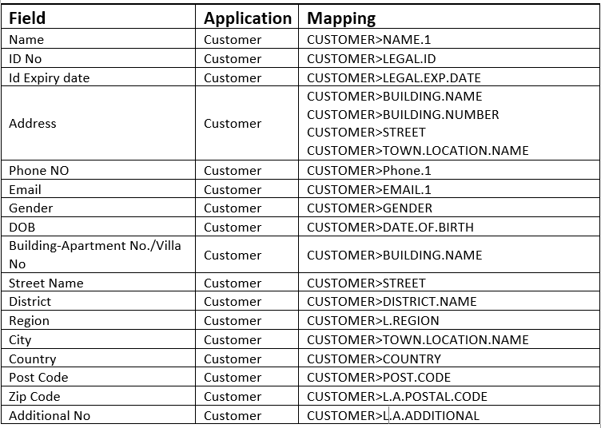
Customer information for CIF 100581 is being fetched from Transact.
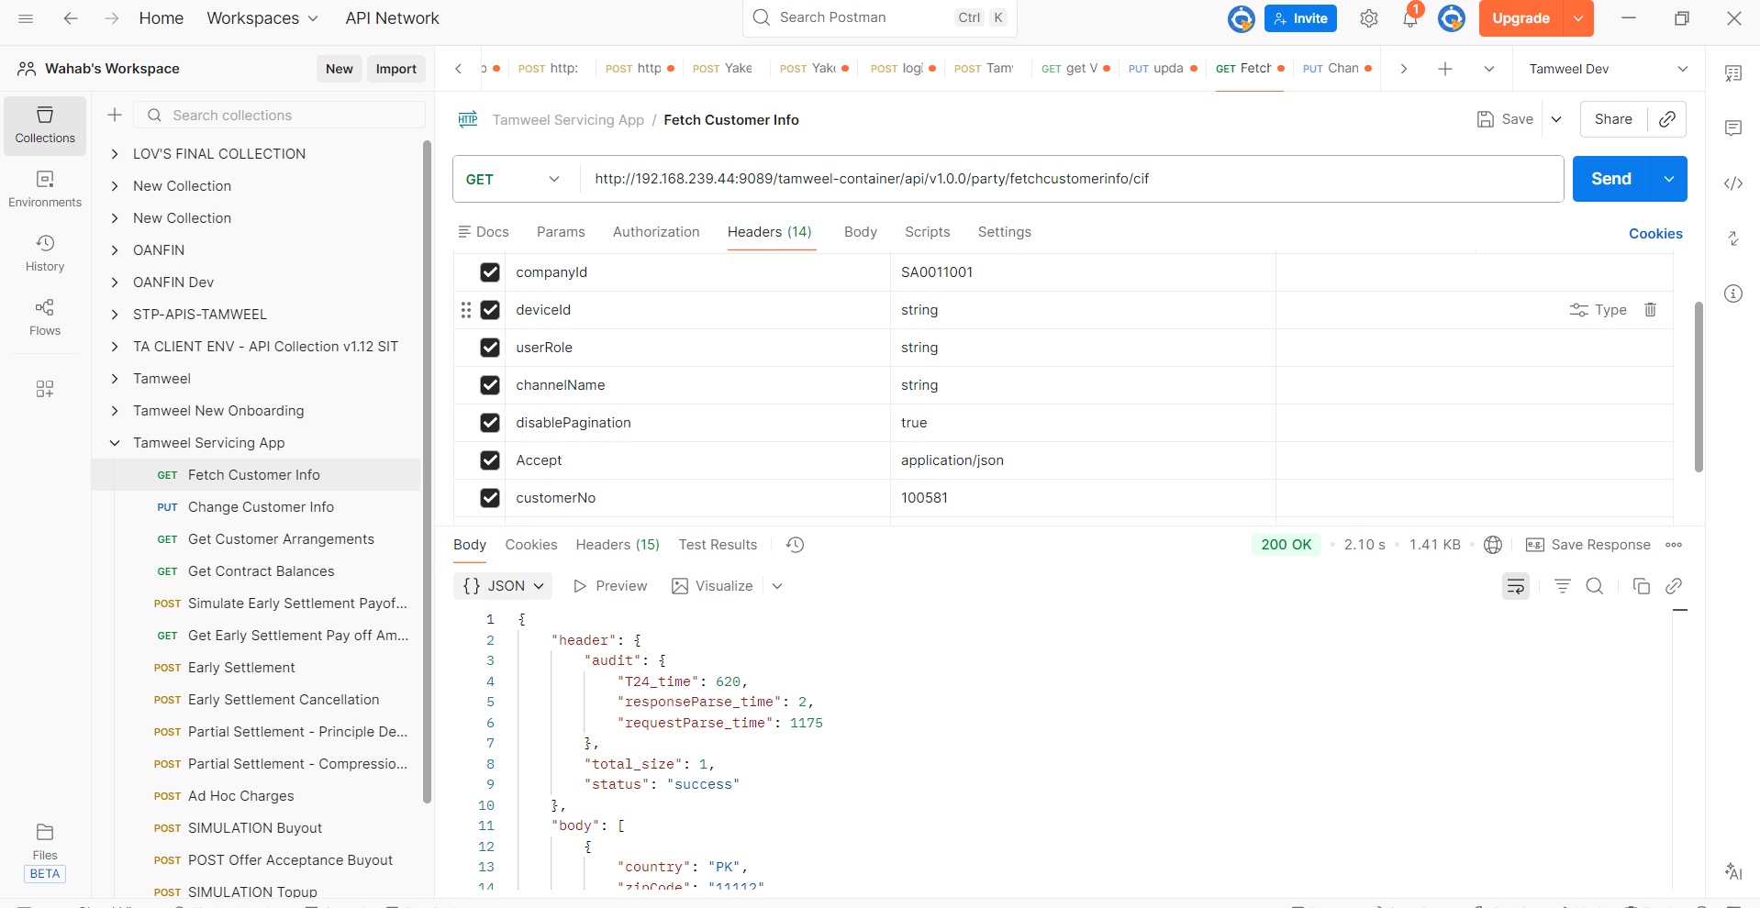
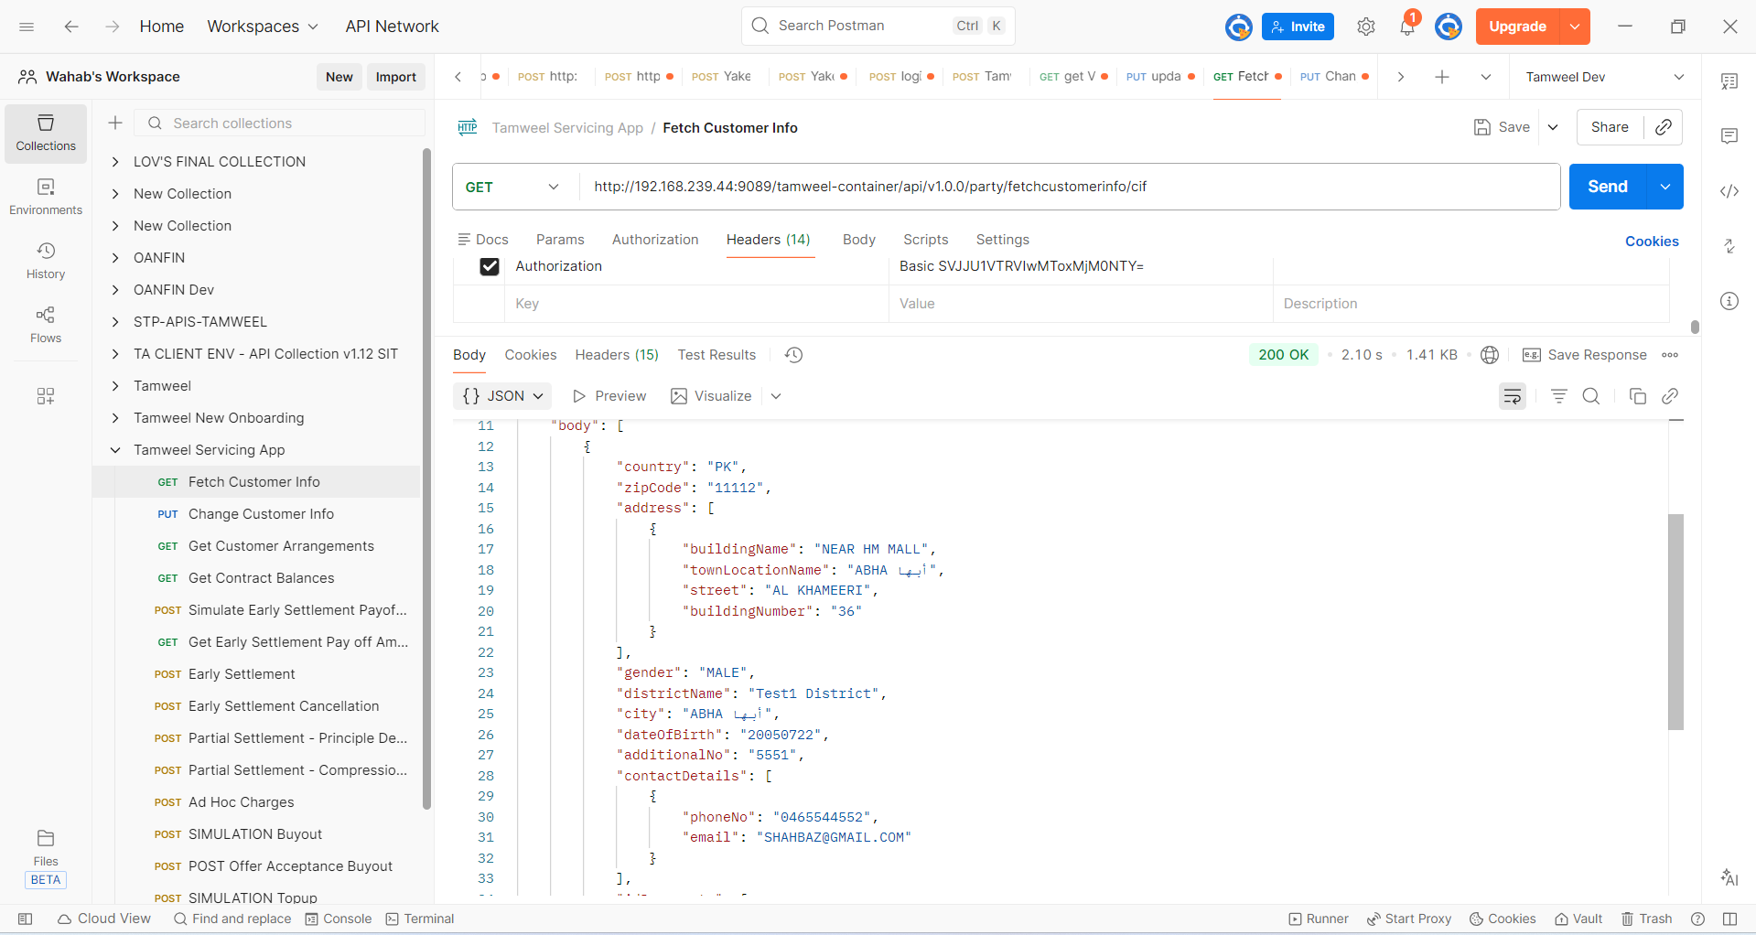
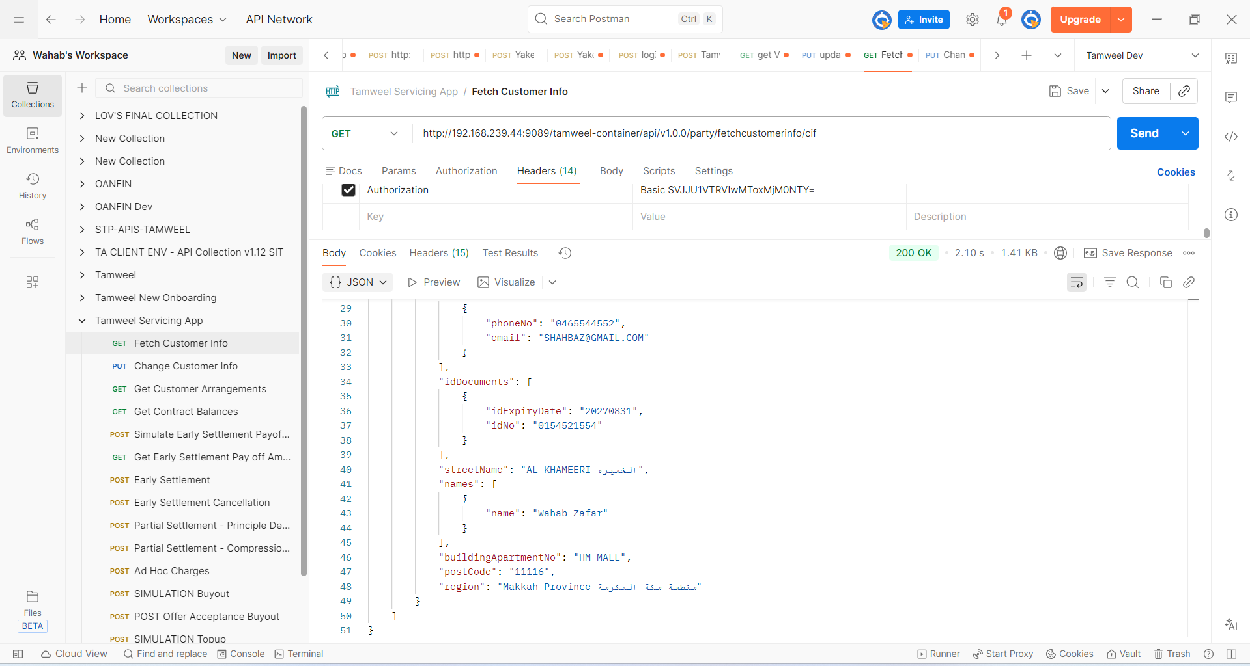
Above is the information which will be fetched.

Change Customer Info
As per BRD below fields were required to be updated on ND.
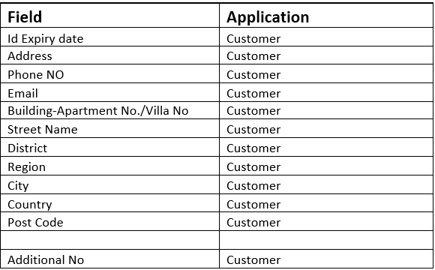

Below is the screenshot before updating the above information on Transact.
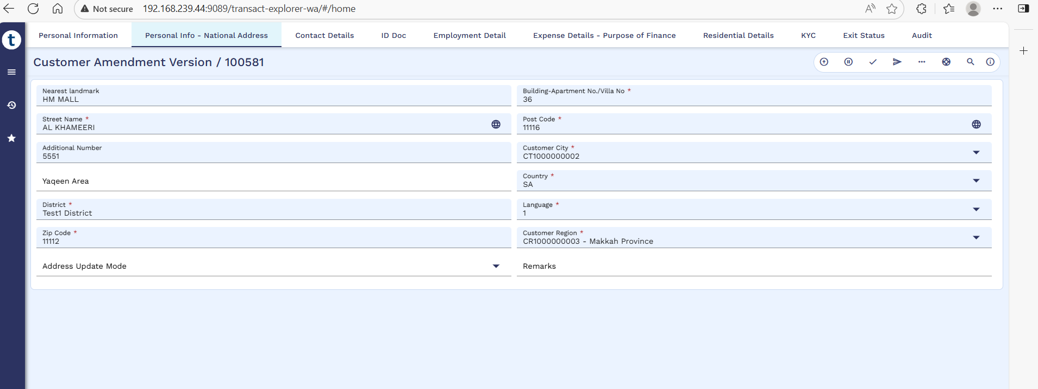
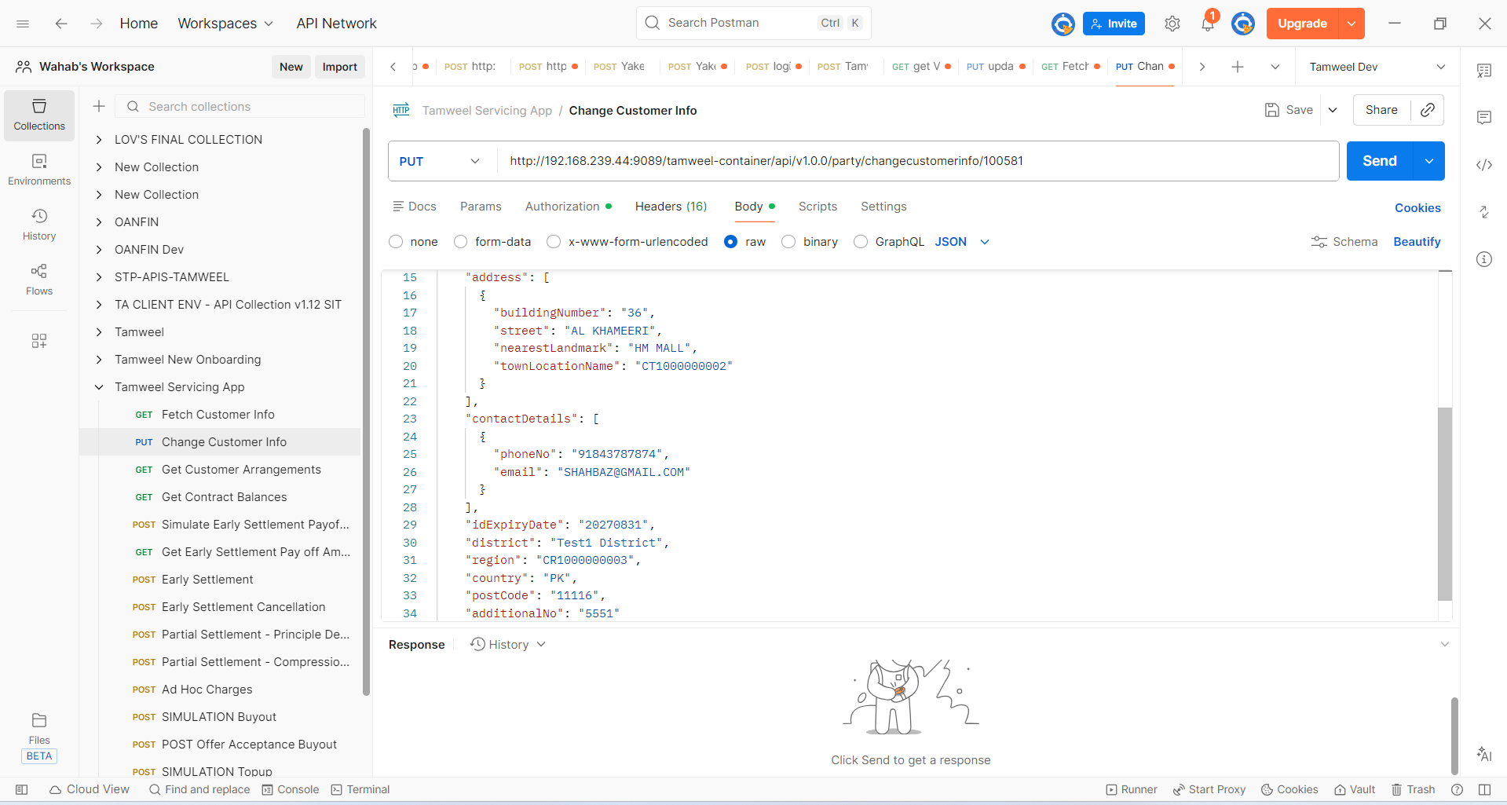

Now when the data is being updated through postman the updated data will be visible to Transact as well.
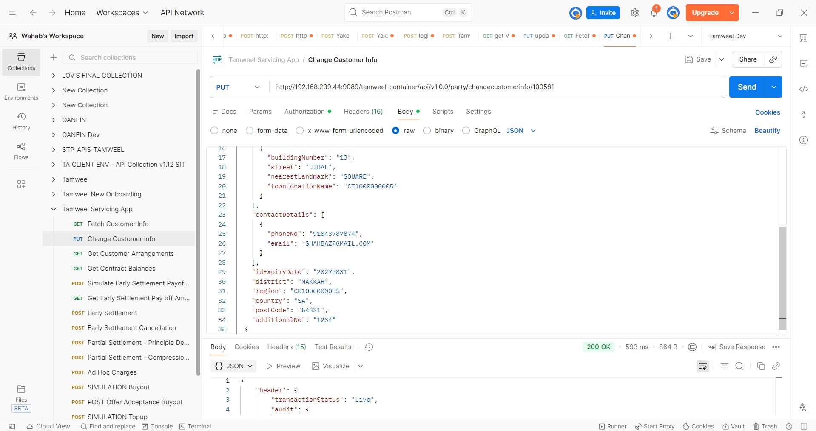
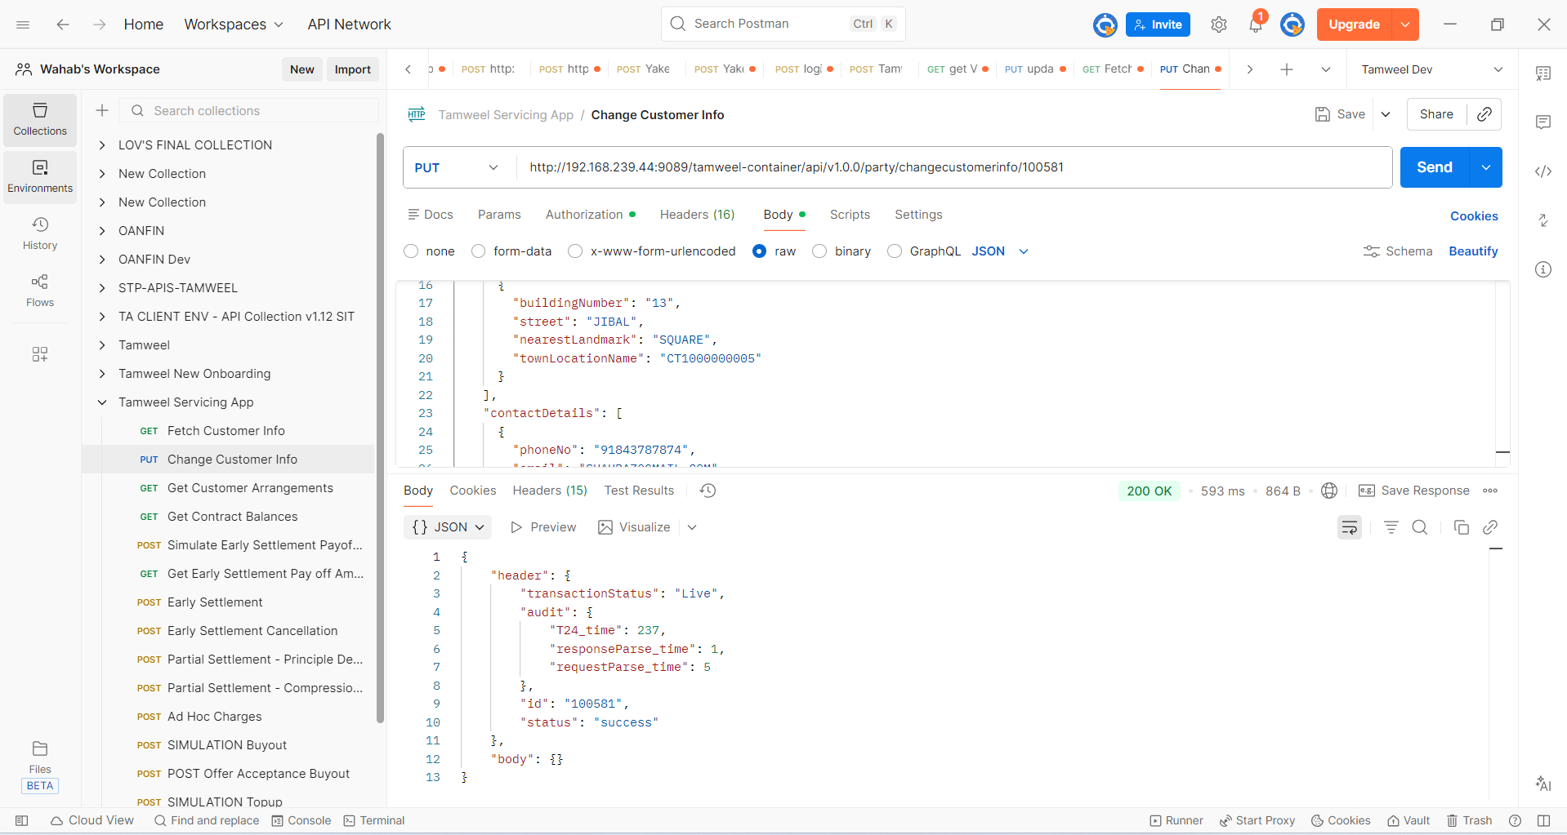
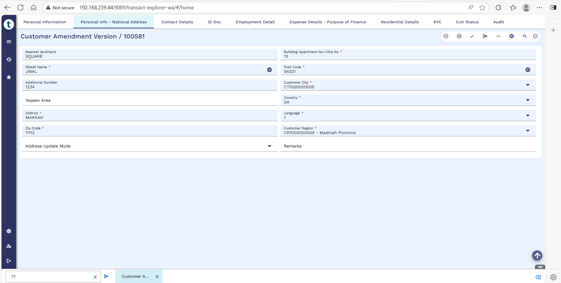

Get Customer Arrangement
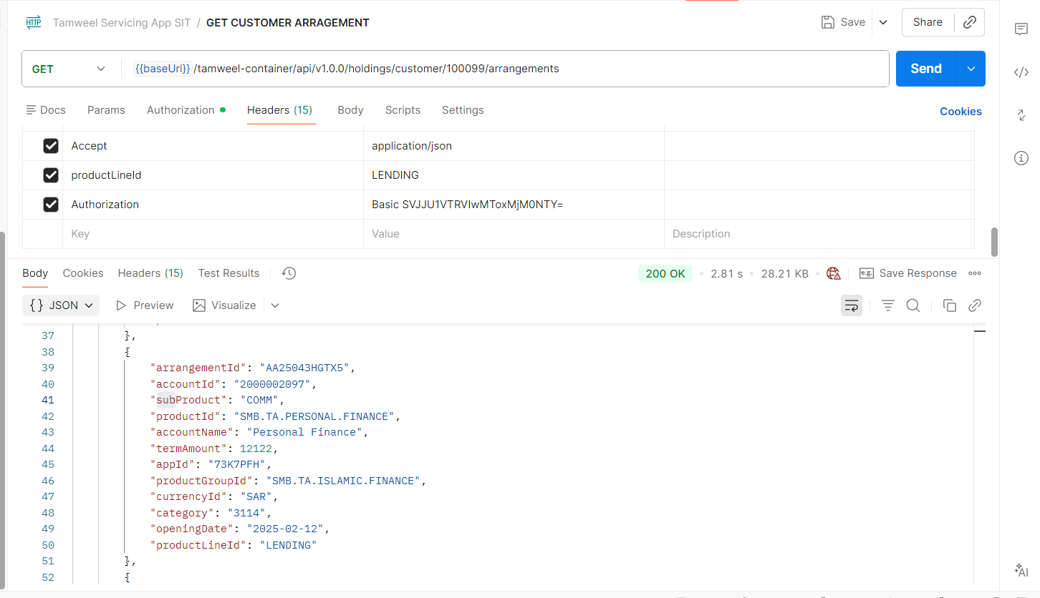
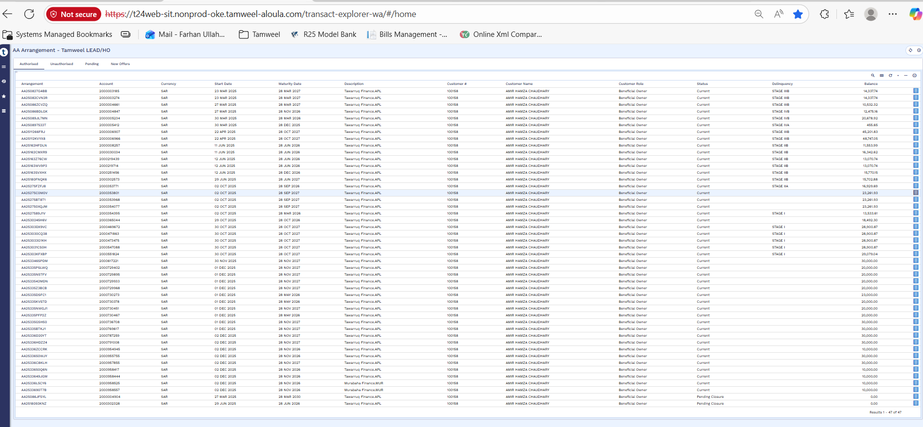

Dashboard
Field | Application | Mapping
Sanctioned Amount | EB.CONTRACT.BALANCES | EB.CONTRACT.BALANCES>CURR.ASSET.TYPE=TOTCOMMITMENT>OPEN.BALANCE
Disbursement Amount | EB.CASH.FLOW | EB.CASHFLOW>VALUE.DATE=CASH.FLOW.DATE>CASH.FLOW.TYPE=PRINCIPAL-ACCOUNT>CASH.FLOW.AMT
Outstanding Principal | EB.CONTRACT.BALANCES | EB.CONTRACT.BALANCES> CURR.ASSET.TYPE=SUM OF ACCOUNT PROPERTY>SUM OF DEBIT.MVMT
Sanctioned Date | EB.CASH.FLOW | EB.CASHFLOW>VALUE.DATE
EMI | EB.CASH.FLOW | EB.CASHFLOW>CASH.FLOW.DATE>CASH.FLOW.TYPE=PRINCIPAL-ACCOUNT>CASH.FLOW.AMT
Profit Rate | SMB.DEAL.DETAILS | SMB.DEAL.DETAILS>SMB.PROFIT.RATE
Tenure | SMB.DEAL.DETAILS | SMB.DEAL.DETAILS>SMB.TENURE
Principal Paid | EB.CASH.FLOW | EB.CASHFLOW>VALUE.DATE=CASH.FLOW.DATE>CASH.FLOW.TYPE=PRINCIPAL-ACCOUNT>CASH.FLOW.AMT (MINUS -) EB.CONTRACT.BALANCES> CURR.ASSET.TYPE=SUM OF ACCOUNT PROPERTY>SUM OF DEBIT.MVMT
Profit Paid | AA.ARR.INTEREST | AA.ACCOUNT.DETAILS>BILL.TYPE=INSTALLMENT>BILL.STATUS=SETTLED>BILL.ID=SELECT ALL BILL IDS, THEN AA.BILL.DETAILS>BILL ID>PROPERTY>DEFERREDPFT>REPAY.AMOUNT  AA.ARR.INTEREST>ACTUAL.PROFIT.AMT (MINUS -) EB.CONTRACT.BALANCES> CURR.ASSET.TYPE=SUM OF INTEREST PROPERTY>SUM OF DEBIT.MVMT
Outstanding Profit | EB.CONTRACT.BALANCES | EB.CONTRACT.BALANCES> CURR.ASSET.TYPE=SUM OF INTEREST PROPERTY>SUM OF DEBIT.MVMT
Tenure Completed | EB.CONTRACT.BALANCES | EB.CONTRACT.BALANCES>CURR.ASSET.TYPE=TOTCOMMITMENT>OPEN.BALANCE
Remaining Tenure | Calculated | Tenure – Tenure Completed
Repayment A/c. Balance | EB.CONTRACT.BALANCES | EB.CONTRACT.BALANCES>WORKING.BALANCE
Profit Rate | SMB.DEAL.DETAIL | SMB.DEAL.DETAIL>PROFIT.RATE
APR | EB.CASH.FLOWS | EB.CASH.FLOWS>CALC.RATE
Sub Product | SMB.DEAL.DETAIL | SMB.DEAL.DETAIL>FIN.SUBTYPE
IBAN No | SMB.DEAL.DETAIL | SMB.DEAL.DETAIL>ACCOUNT.ID
Asset Price | EB.SMB.L.ASSET.DETAILS,STP.ASSET.DETAIL | EB.SMB.L.ASSET.DETAILS,STP.ASSET.DETAIL>UNIT.PRICE
Down Payment | EB.SMB.L.ASSET.DETAILS,STP.ASSET.DETAIL | EB.SMB.L.ASSET.DETAILS,STP.ASSET.DETAIL>DOWNPAYMENT.AMOUNT
RV Amount | EB.SMB.L.ASSET.DETAILS,STP.ASSET.DETAIL | EB.SMB.L.ASSET.DETAILS,STP.ASSET.DETAIL>RV.AMOUNT
Insurance Amount | EB.SMB.L.ASSET.DETAILS,STP.ASSET.DETAIL | EB.SMB.L.ASSET.DETAILS,STP.ASSET.DETAIL>INSURANCE.AMOUNT
Interest Amount | Calculation | ADD PROFIT OUTSTANDING+PROFIT PAID
No of Installment Overdue | AA.BILL.DETAILS | AA.BILL.DETAILS>COUNT DUE BILLS
Principal Overdue | Calculation | OUTSTANDING PRINCIPAL - CURACCOUNT
Interest Overdue | Calculation | OUTSTANDING PROFIT - RECDEFERREDPFT
No of installment Paid | AA.BILL.DETAILS | AA.BILL.DETAILS>COUNT SETTLED BILLS
Charges | EB.CASH.FLOWS | EB.CASH.FLOWS>Check Property ADMINFEEUP
Next EMI Date | EB.CASH.FLOWS | EB.CASH.FLOWS>check next installment date

Get Contract Balances
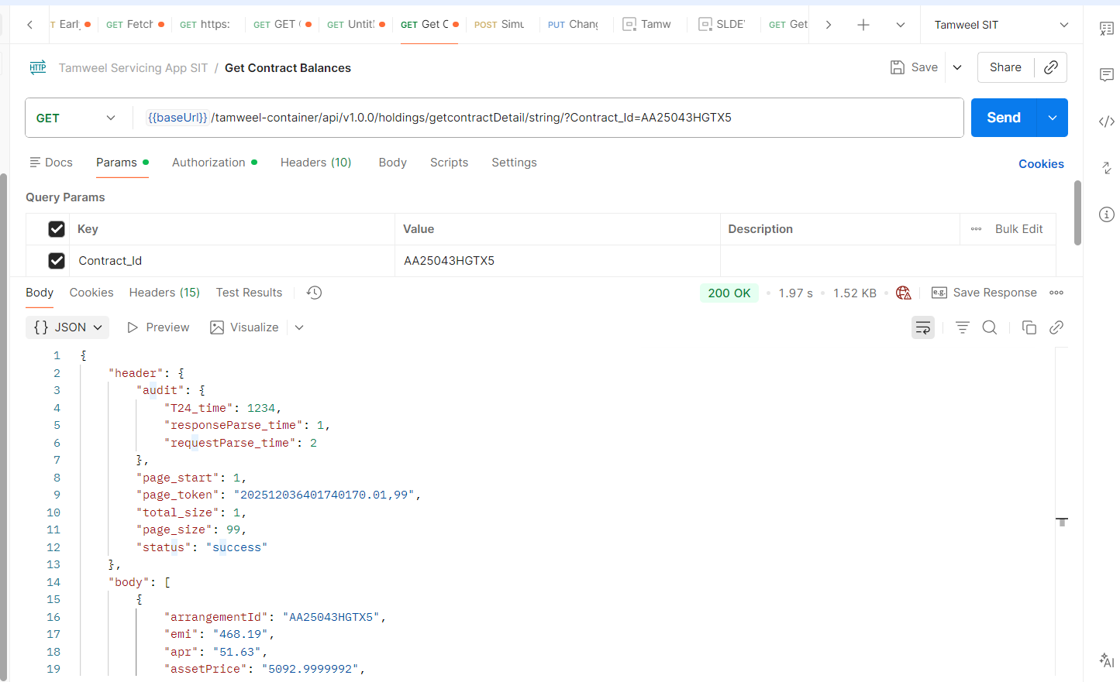
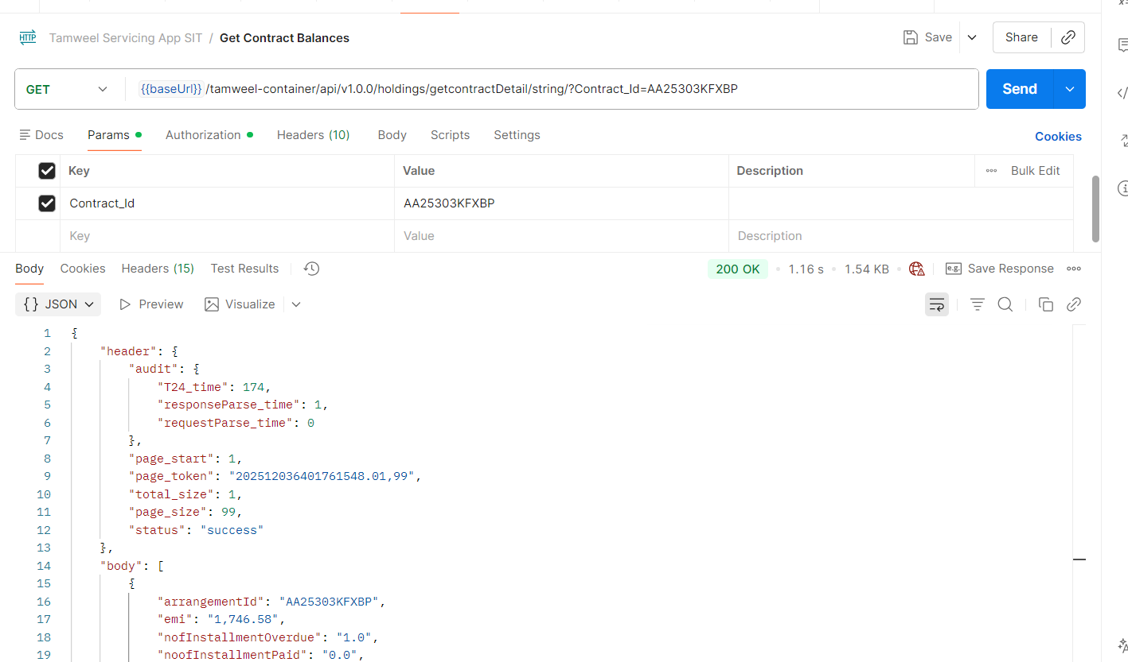
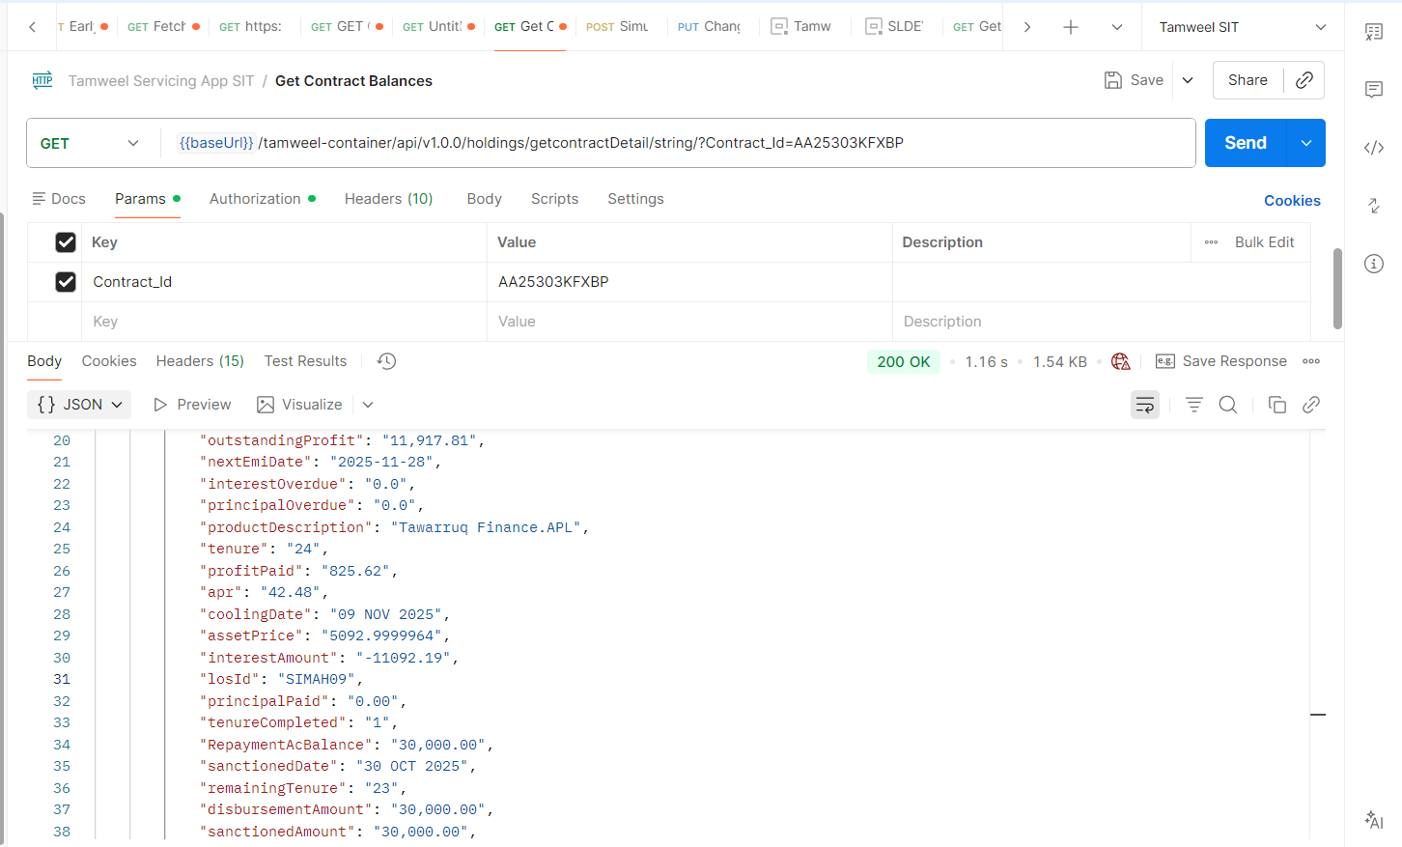
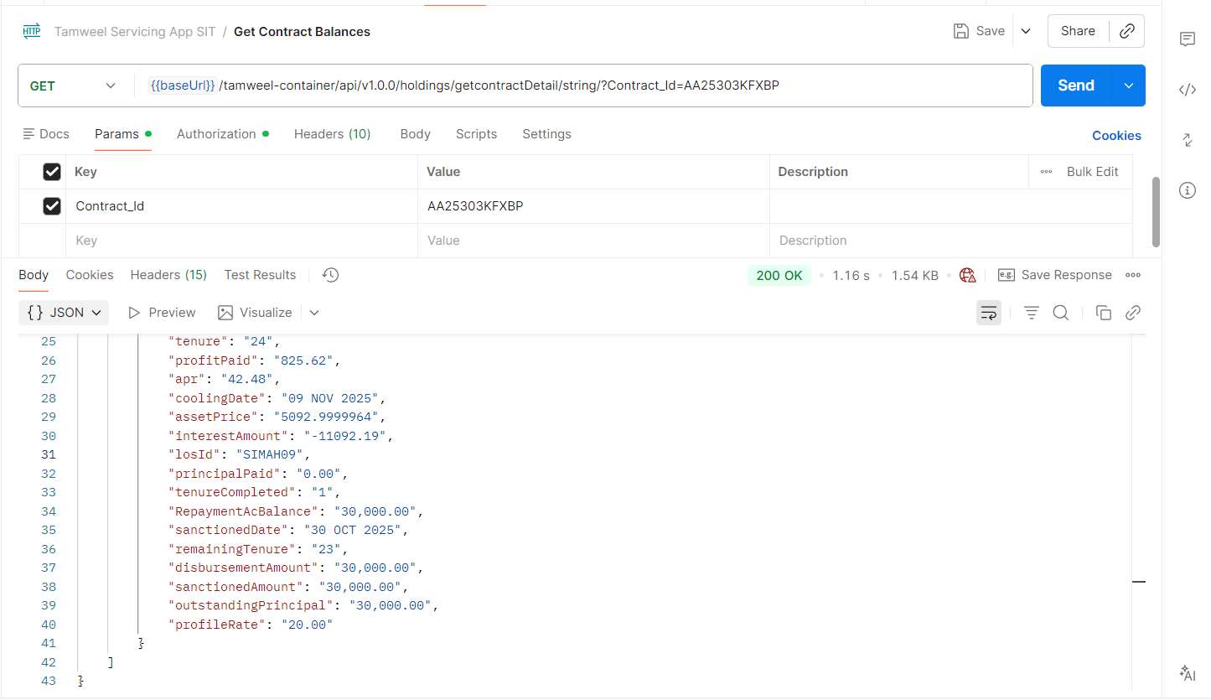

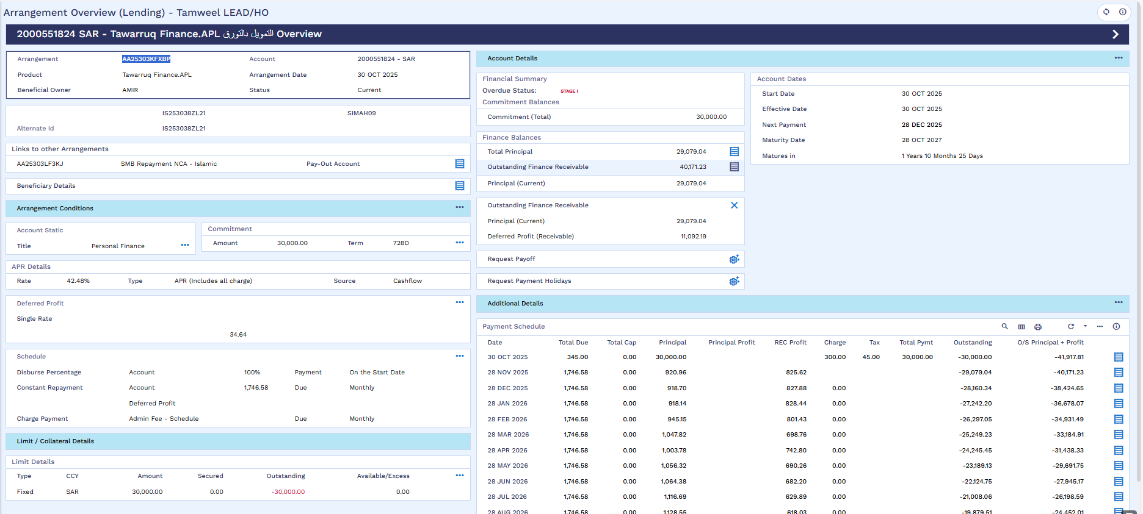

Simulate Early Settlement Payoff Amount
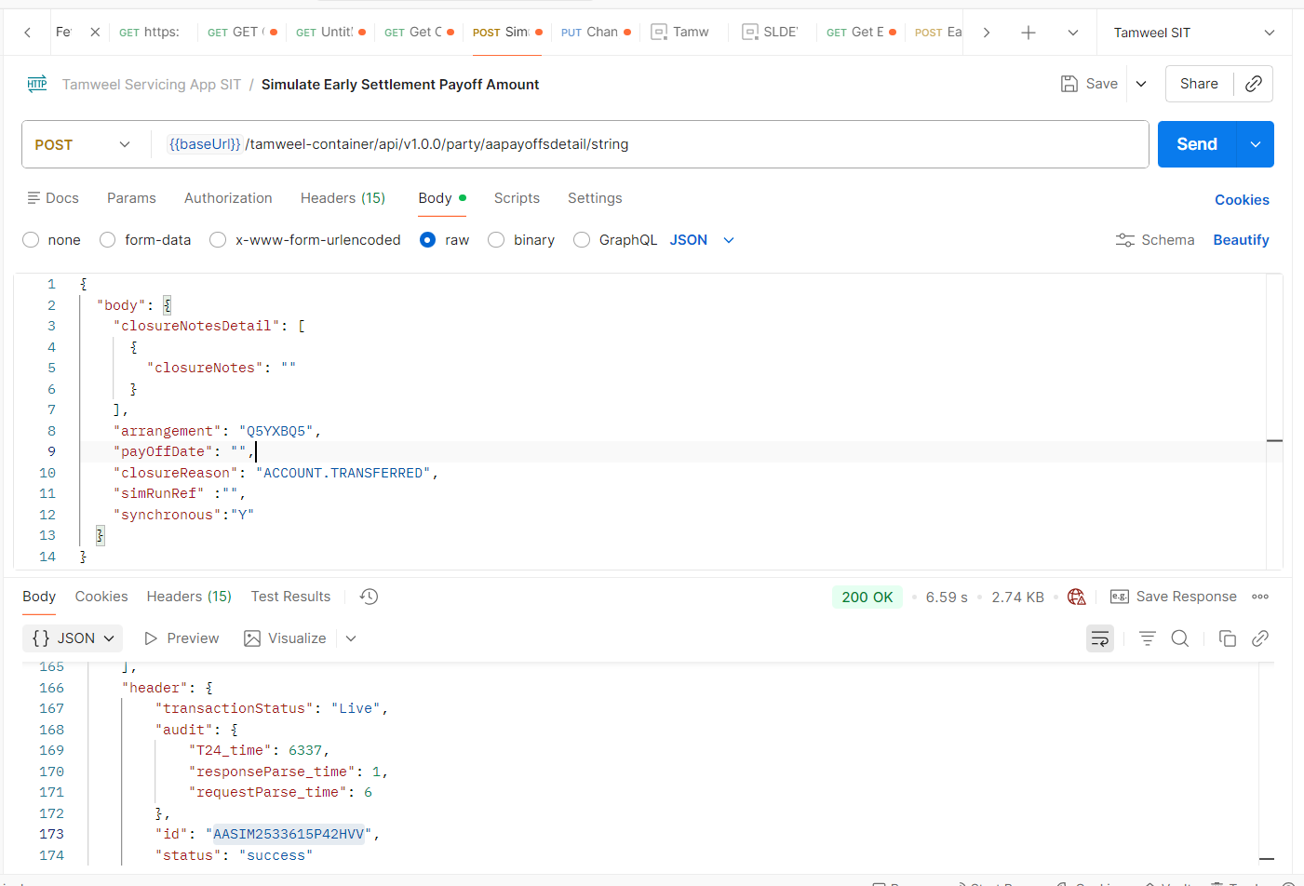

Get Early Settlement Payoff Amount
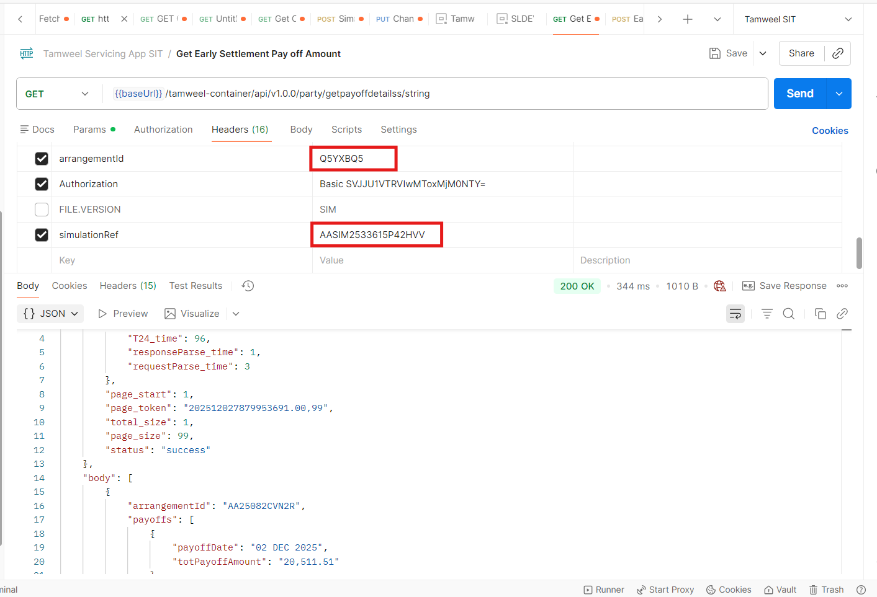

Early Settlement
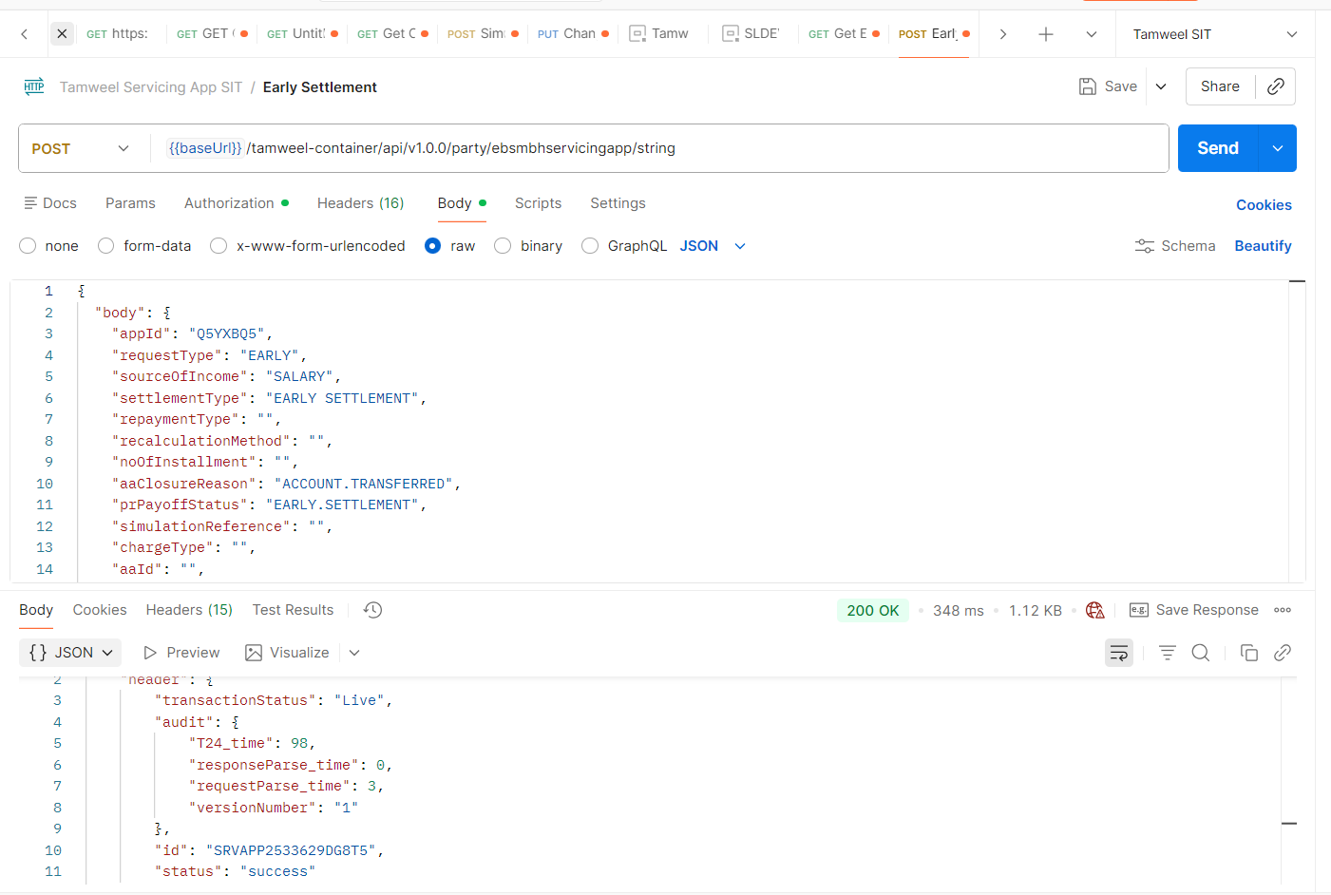
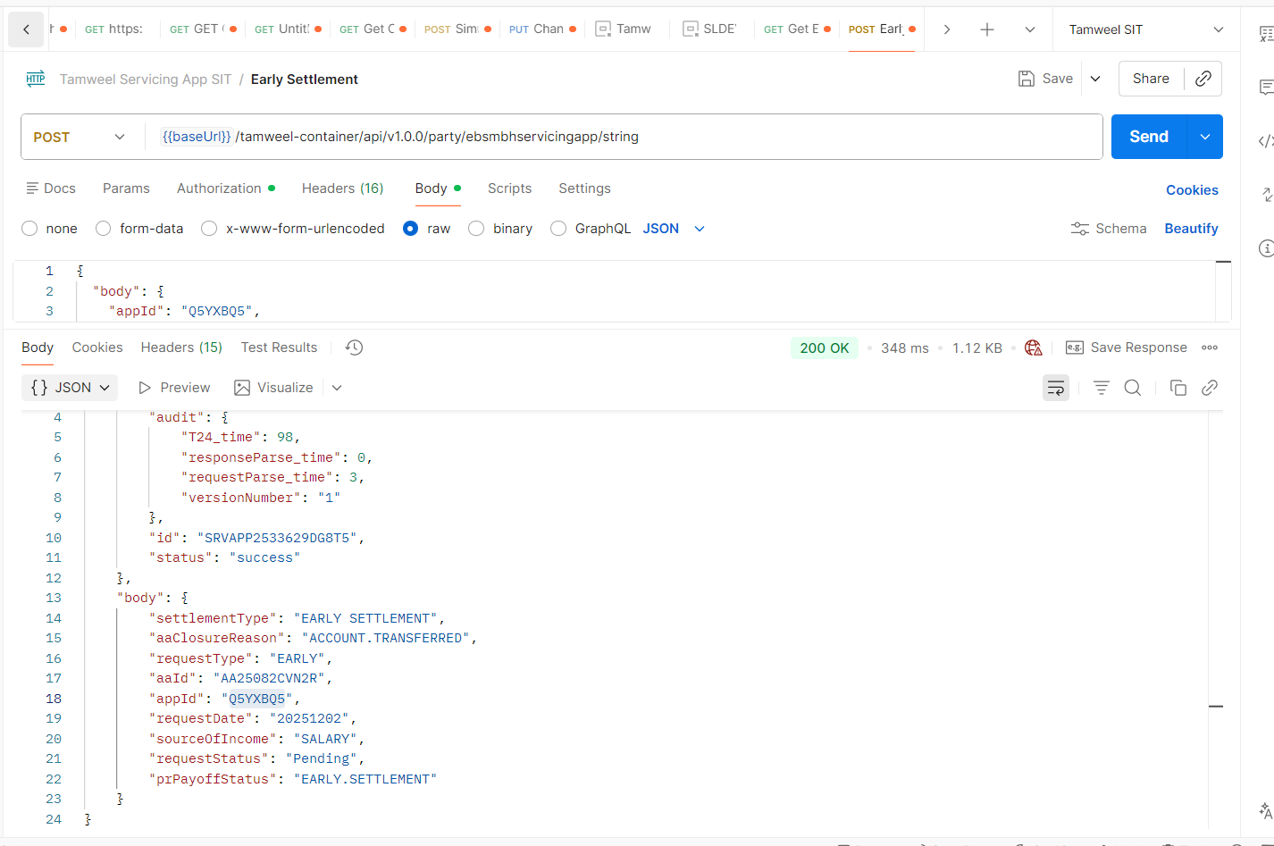
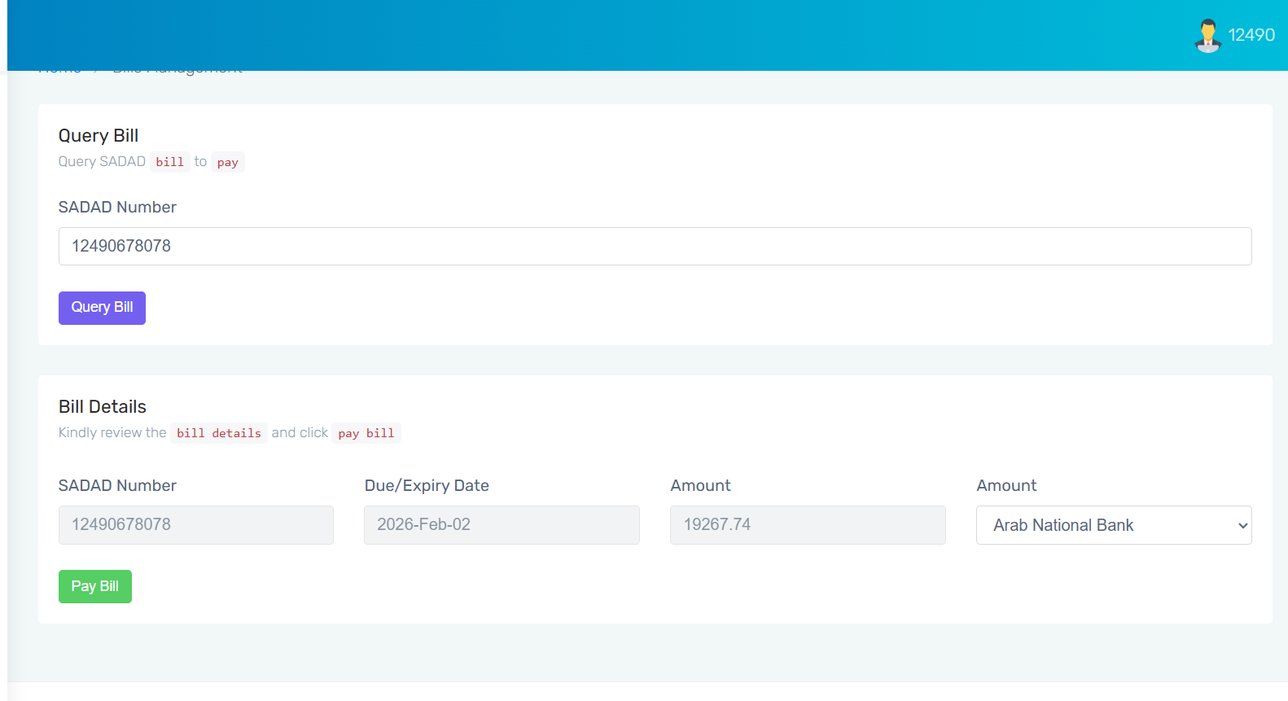
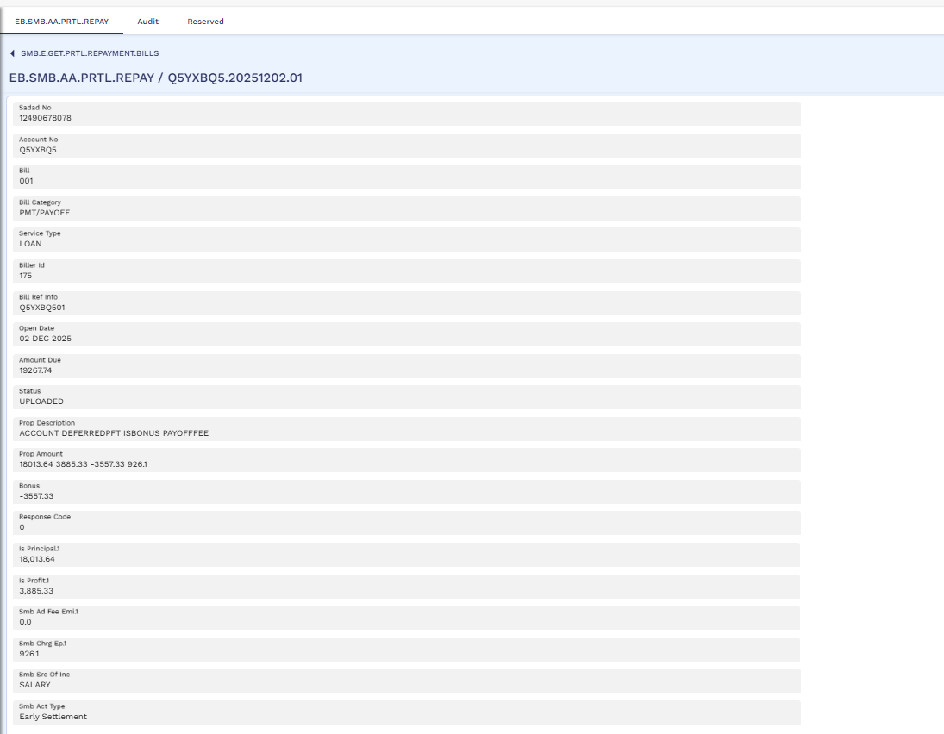
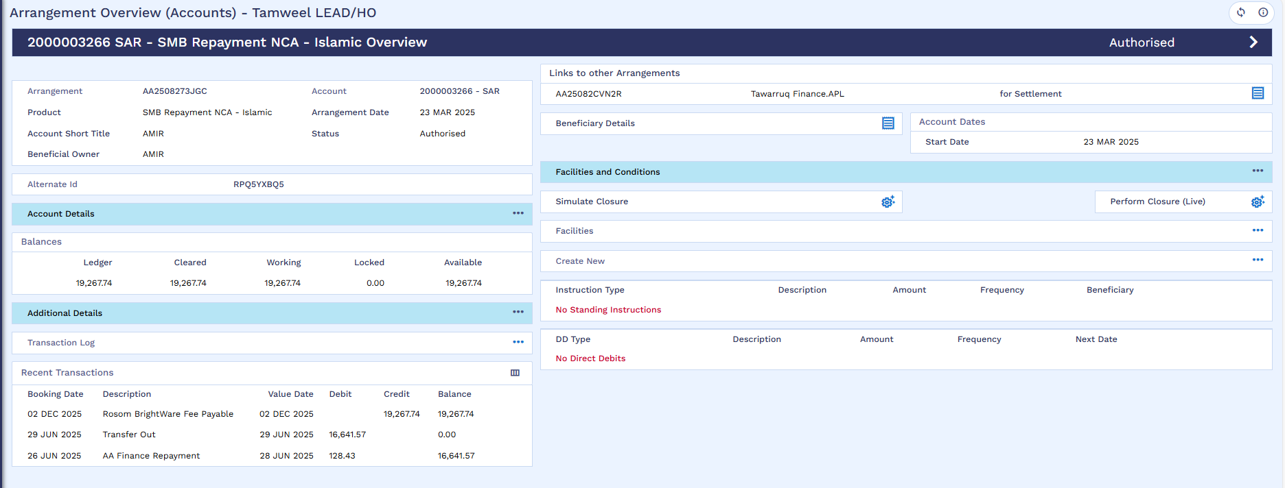

Cancellation Simulation
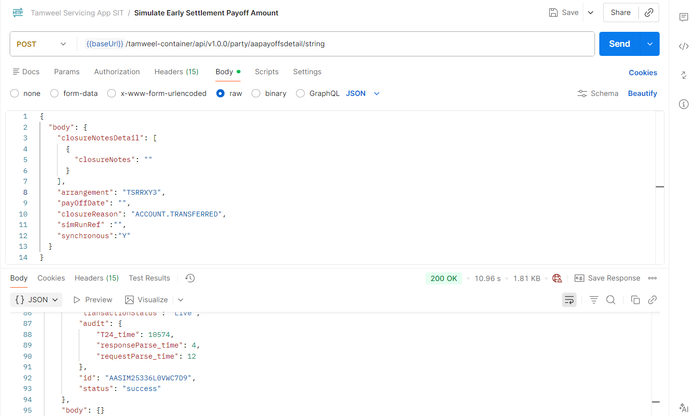

Get Cancellation Payoff Amount
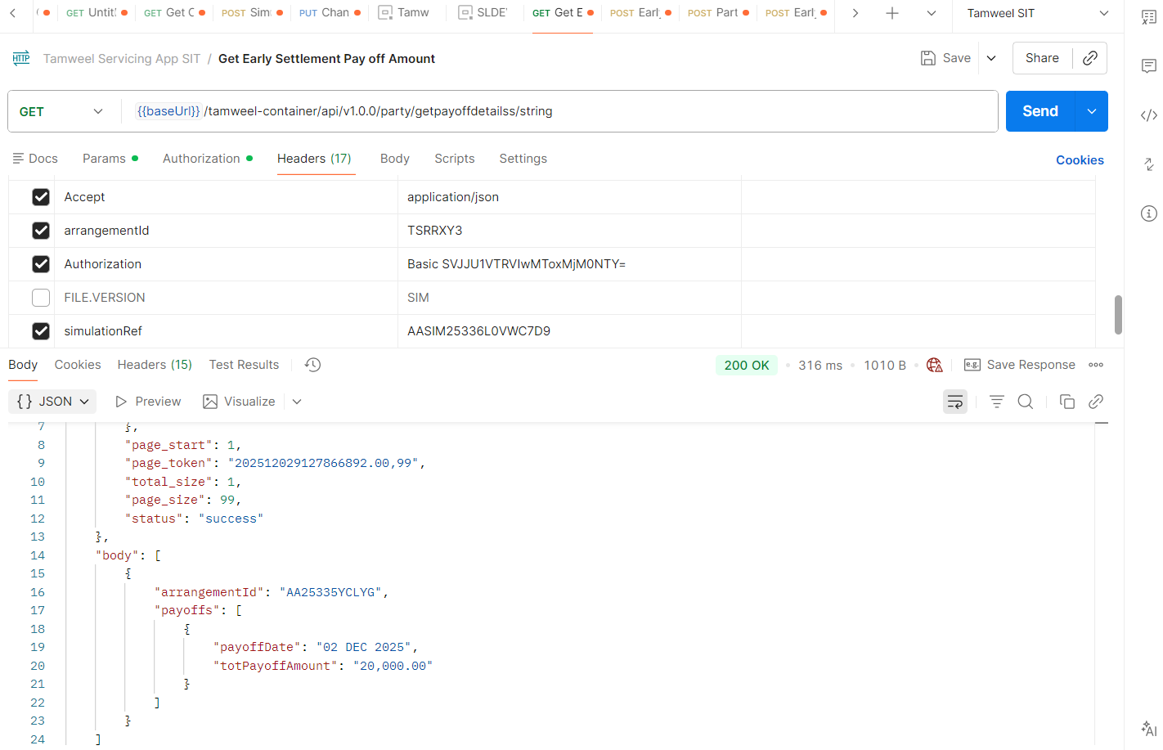

Cancellation
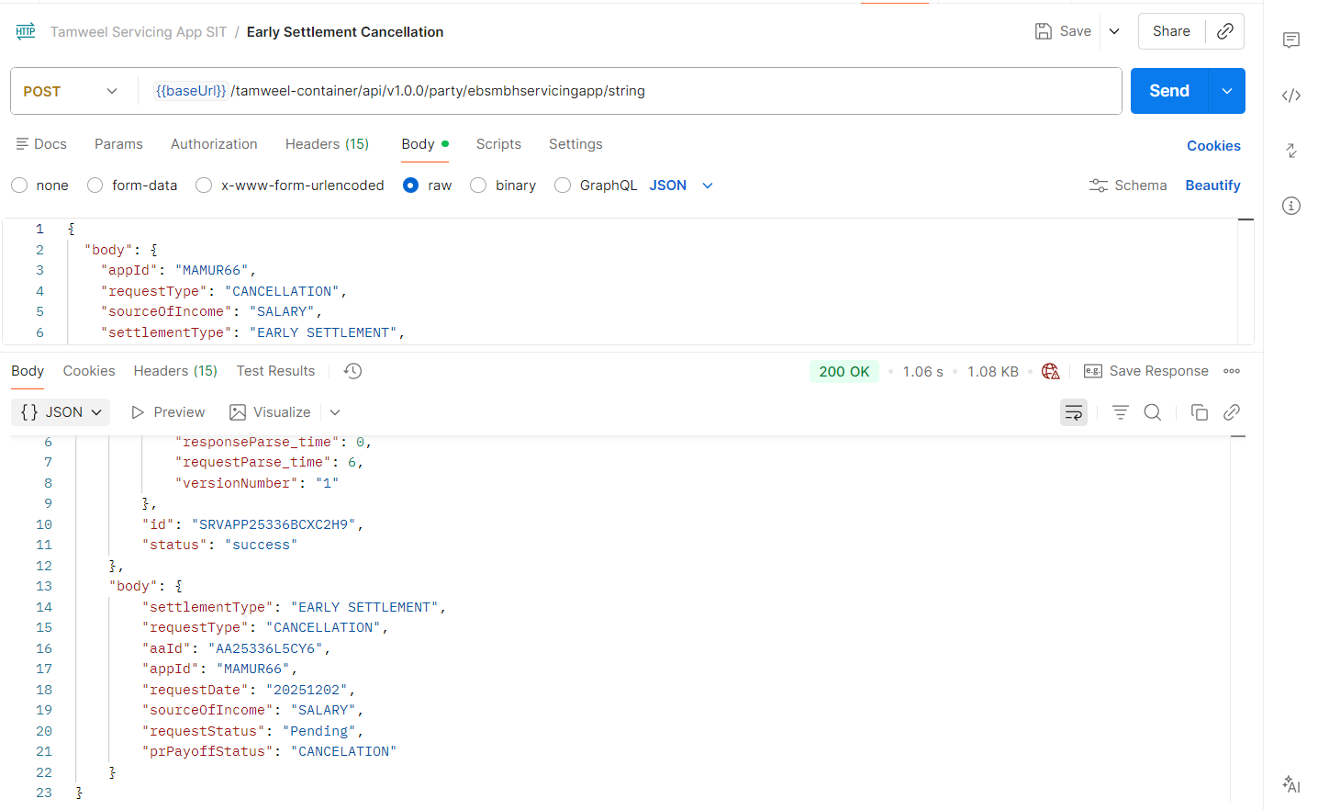
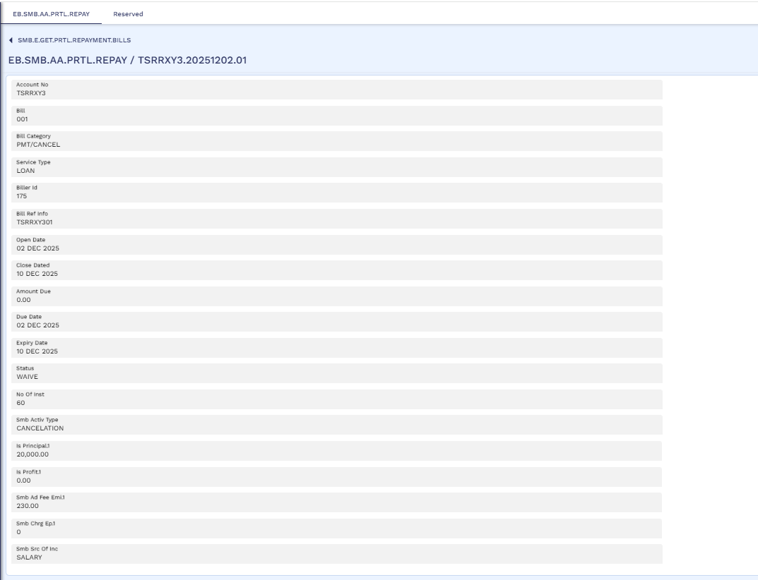
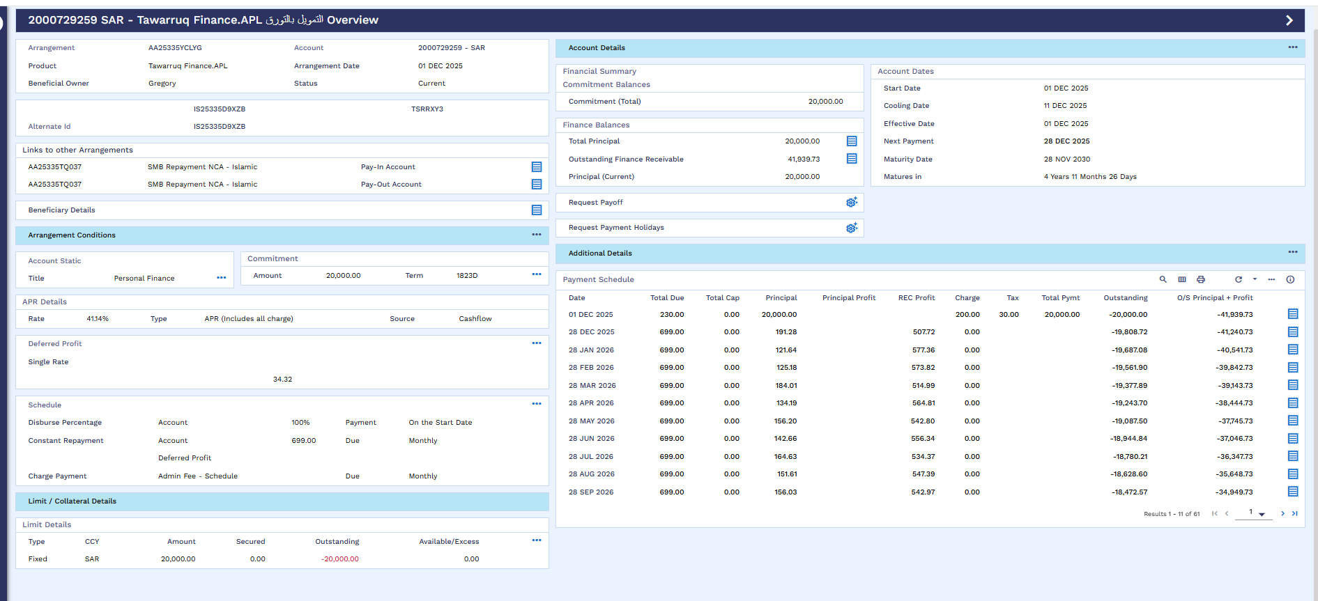

Partial Settlement – Principal Decrease
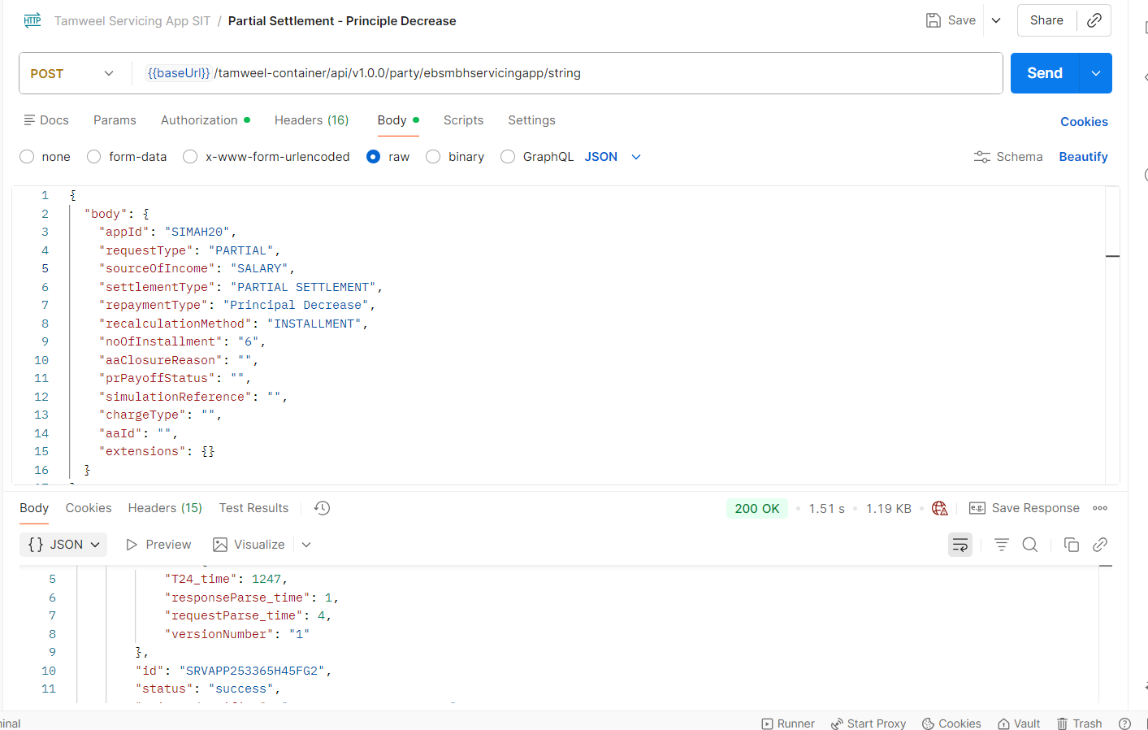
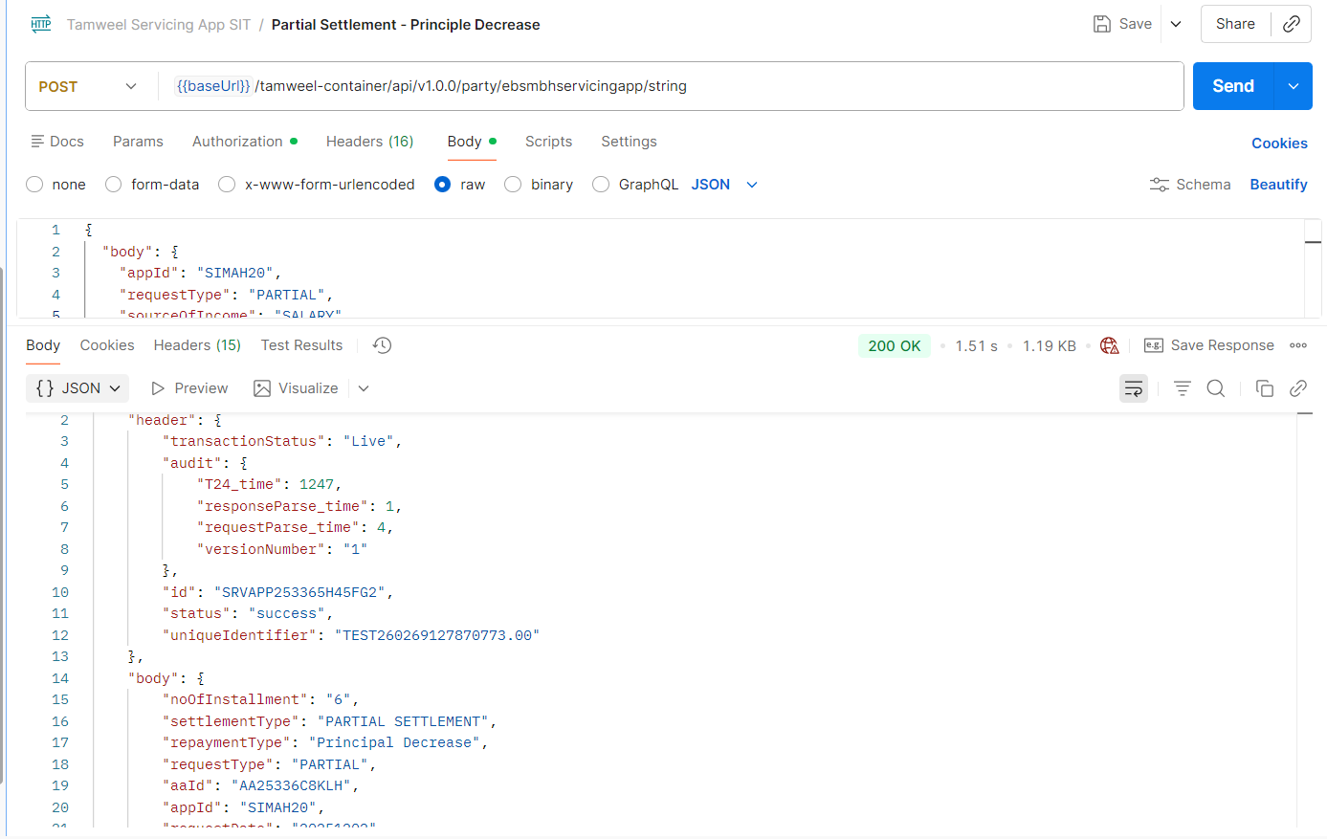
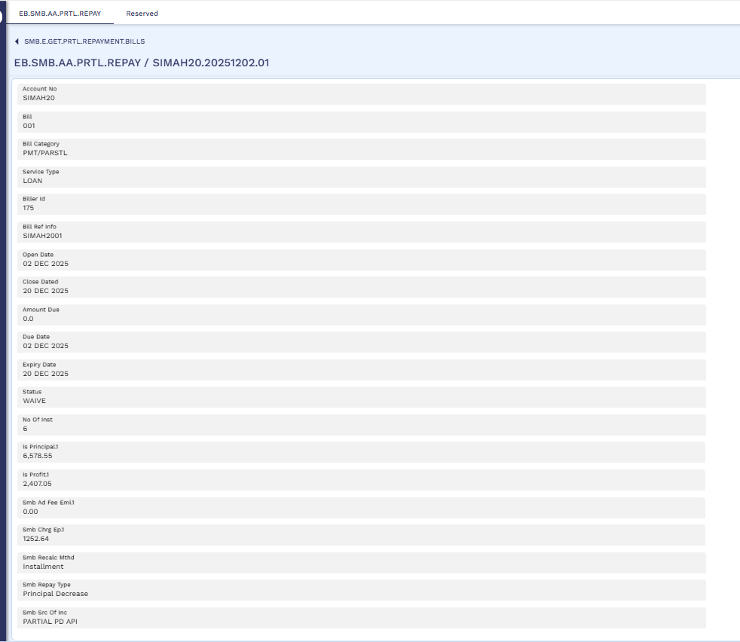

Partial Settlement – Compression
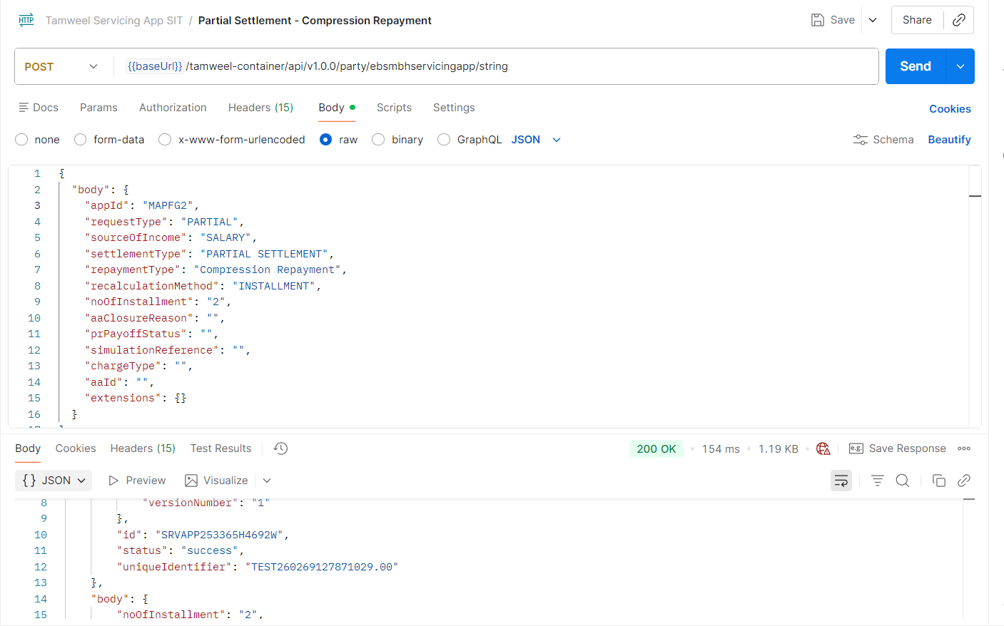
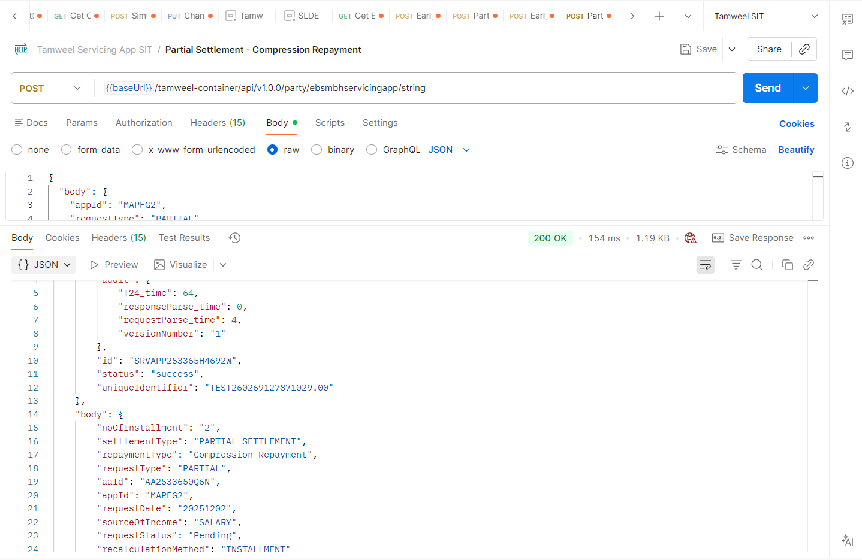
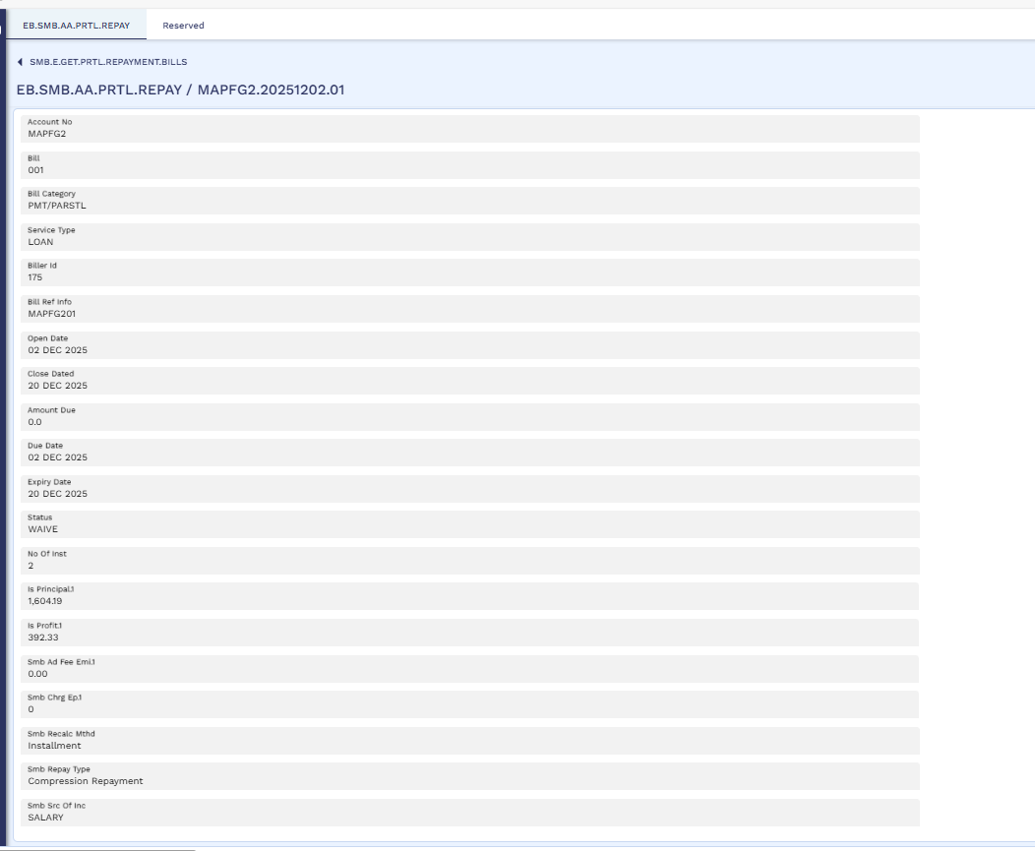

Buy-Out Facility
For buy-out facility below process will be followed where the requested amount by the customer must equal to the loan amount of other financial institution.
AA Simulation Capture
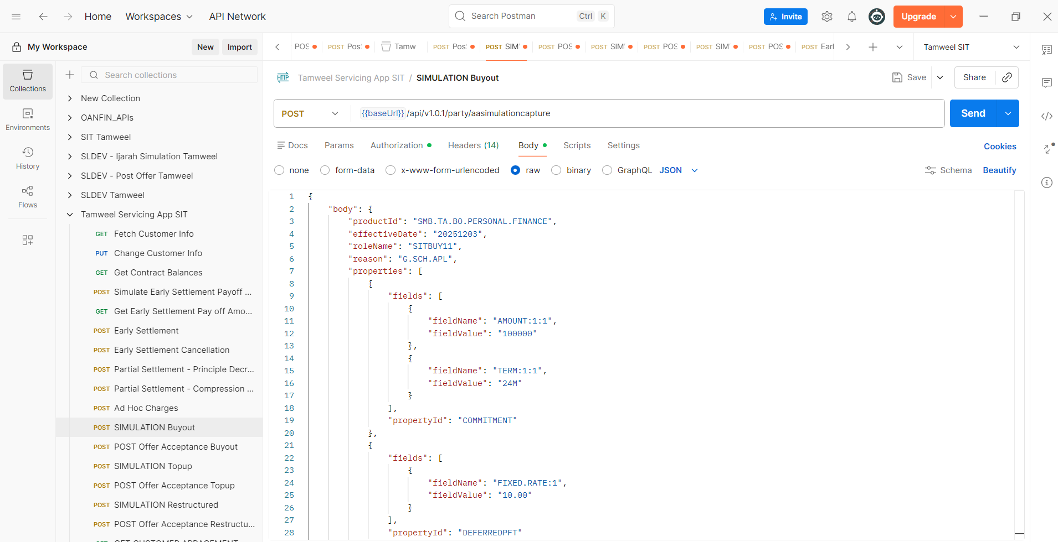
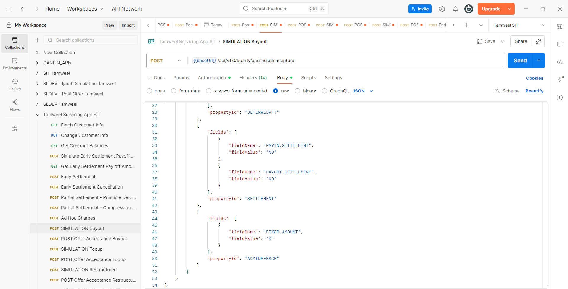
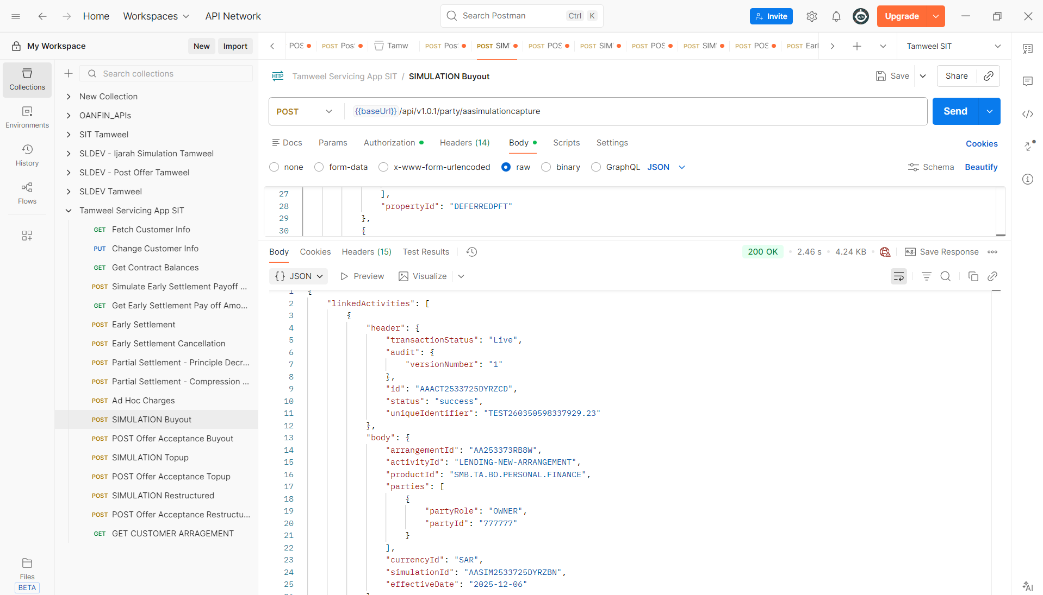
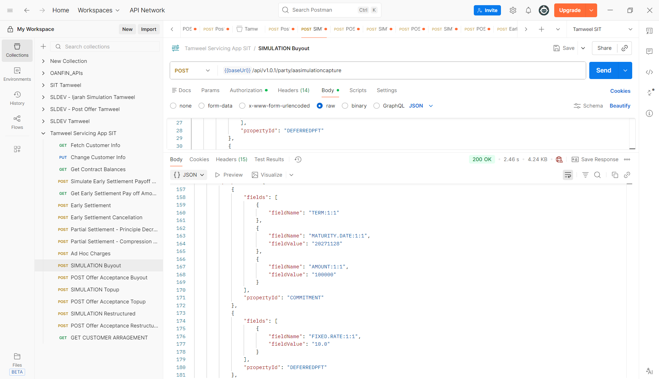

AA Simulation
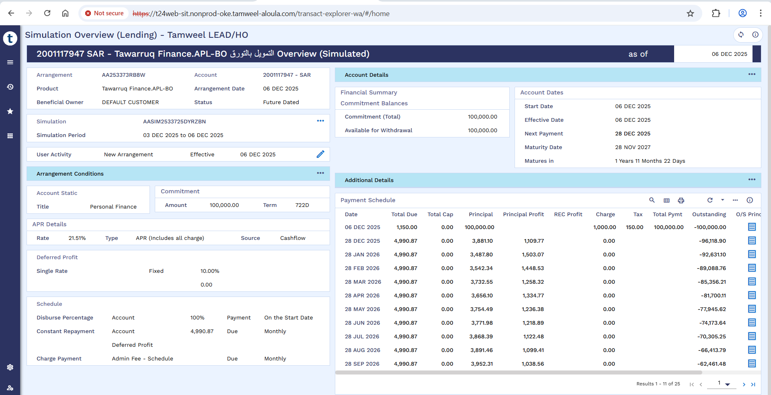
Post Offer Acceptance Buy-Out
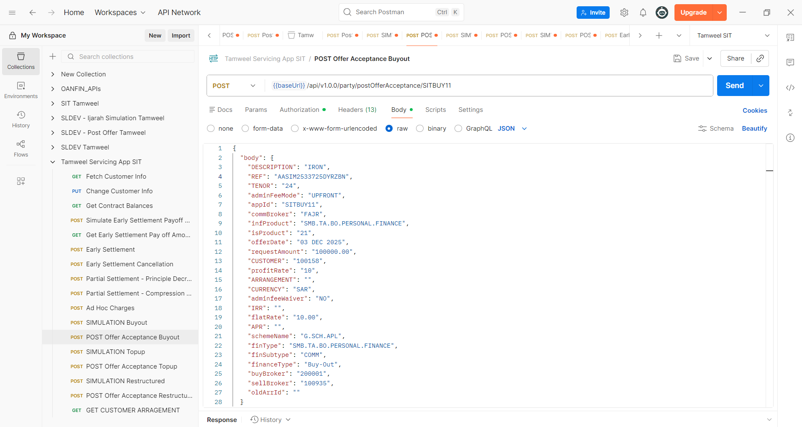

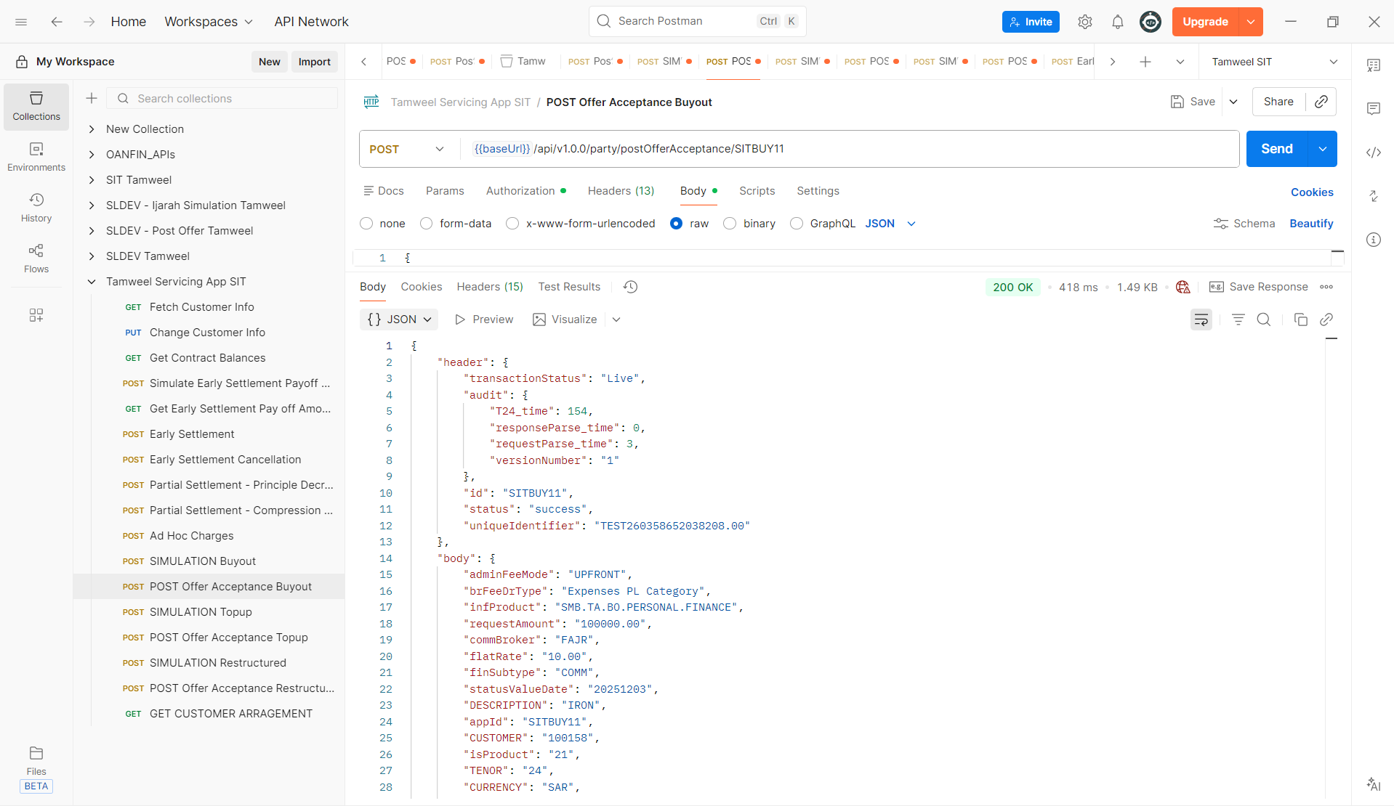
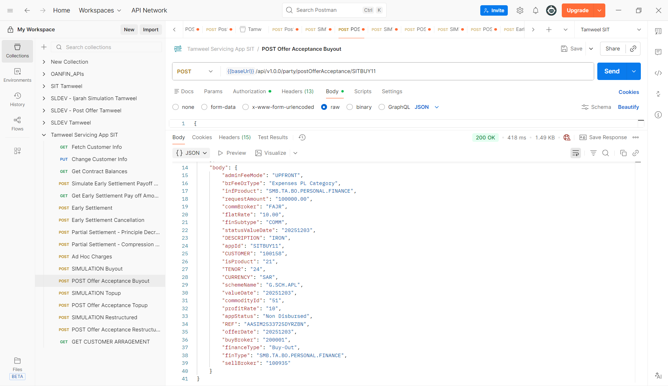

SMB DEAL DETAIL
The system successfully populates the SMB.DEAL.DETAIL template with all relevant Buy-Out Facility details.
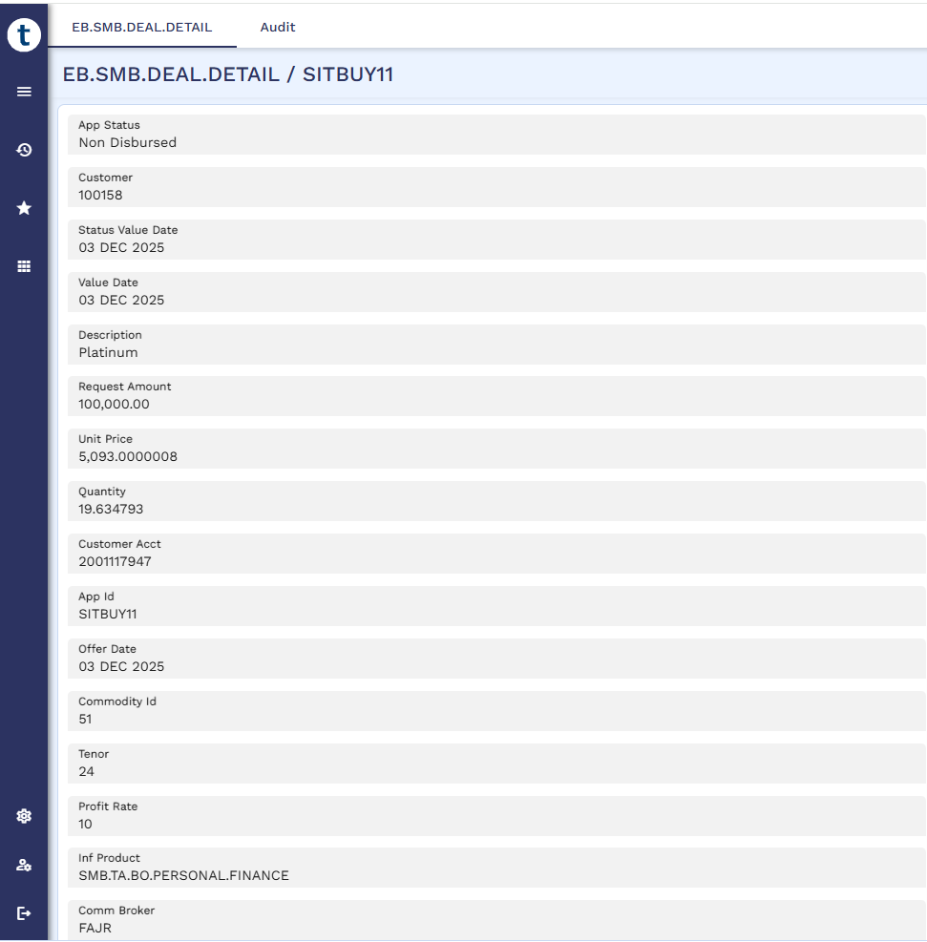
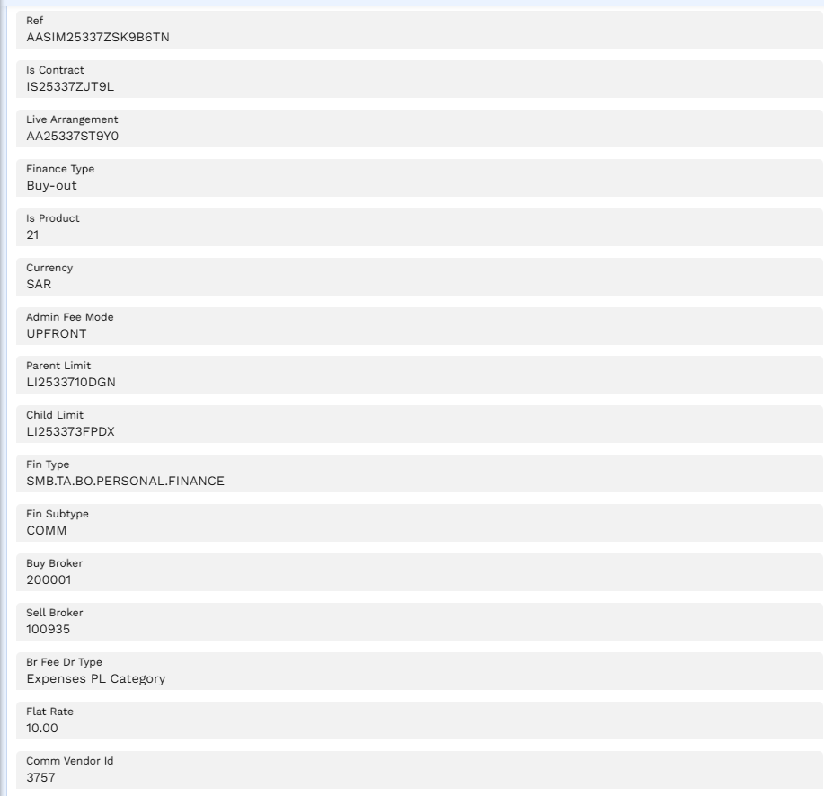
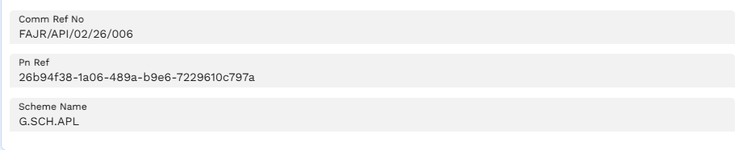

STP Status Enquiry
Below screen shows successful end-to-end STP completion.
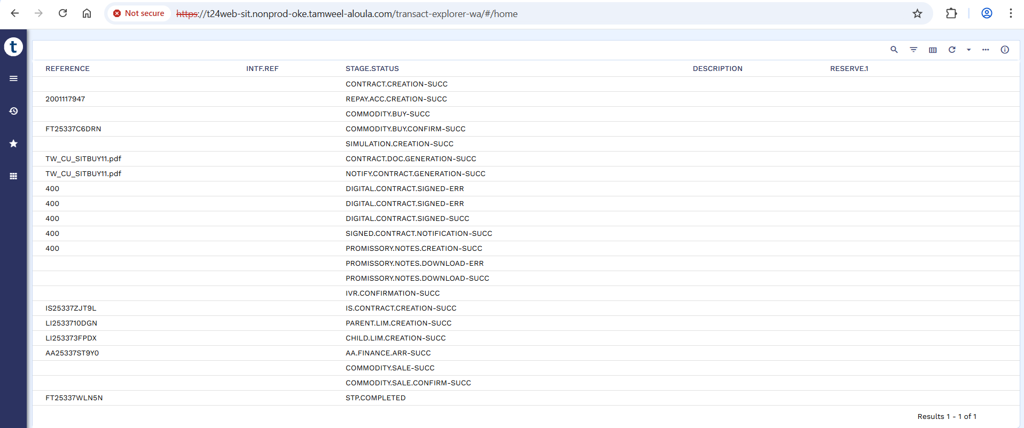
Arrangement
The arrangement is successfully created in Transact upon completion of STP.

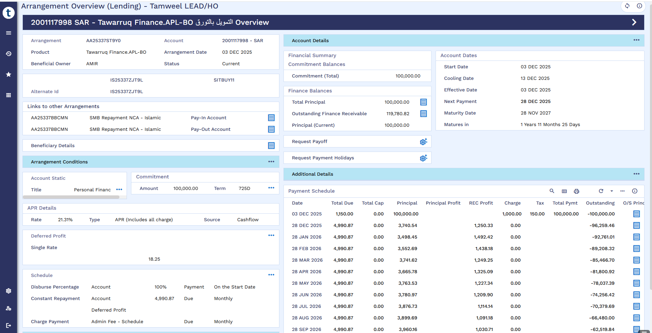

STP Entries
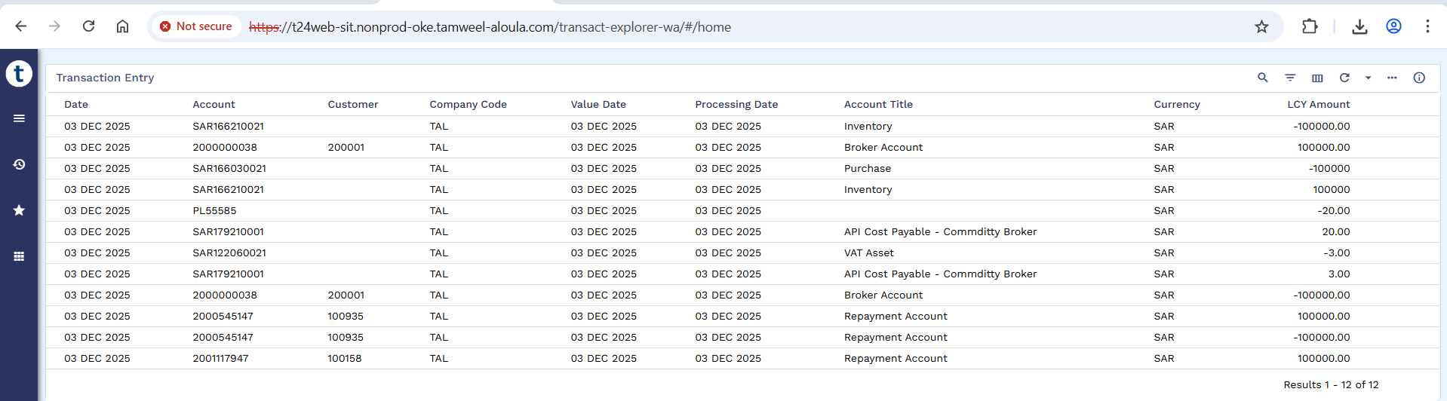
Transaction Entries
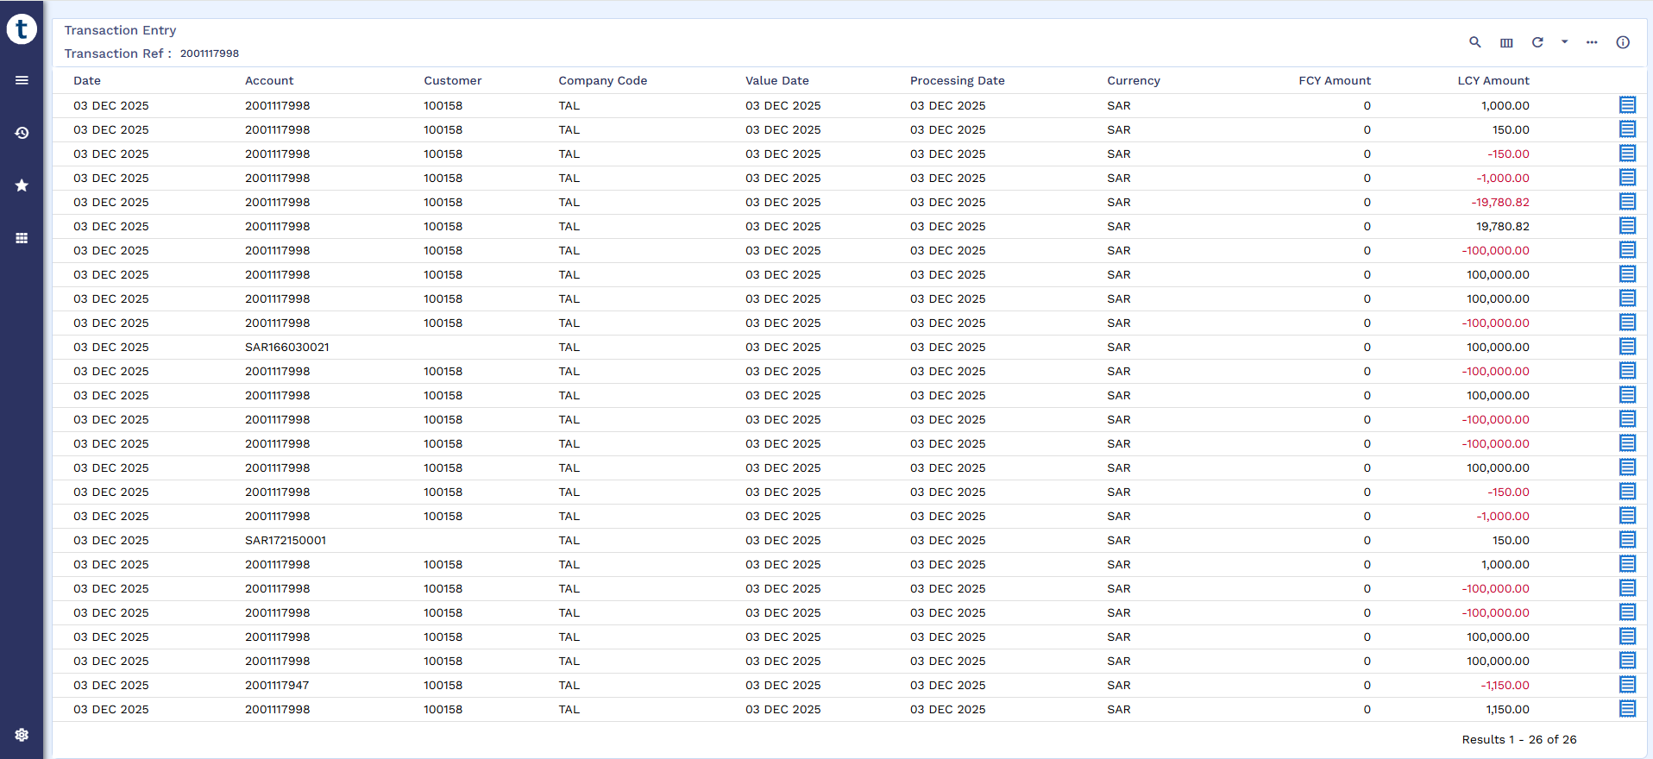

Restructure Facility
Simulate Early Settlement Payoff Amount
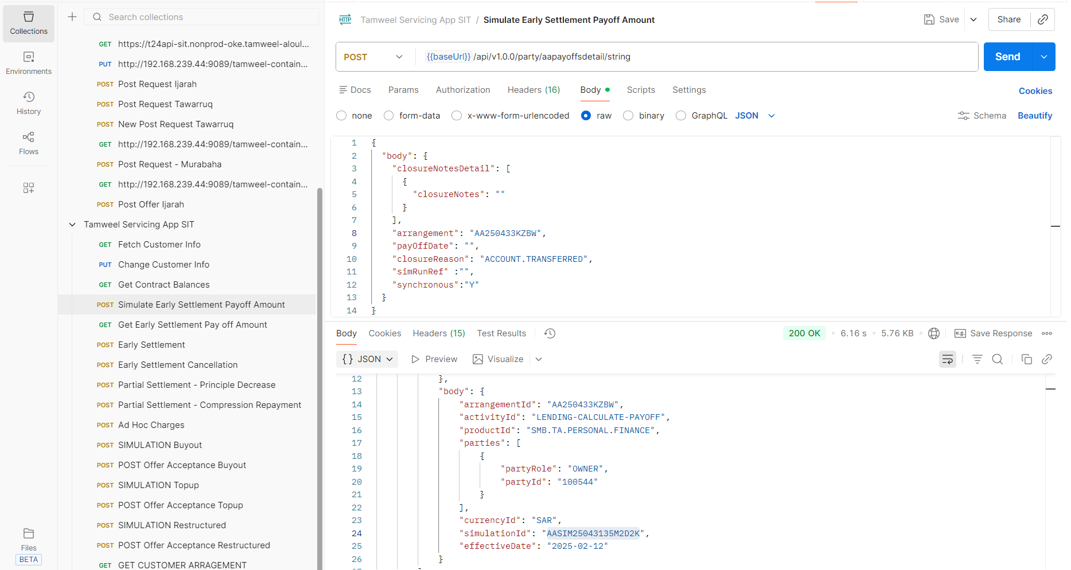
Early Settlement Pay off Amount
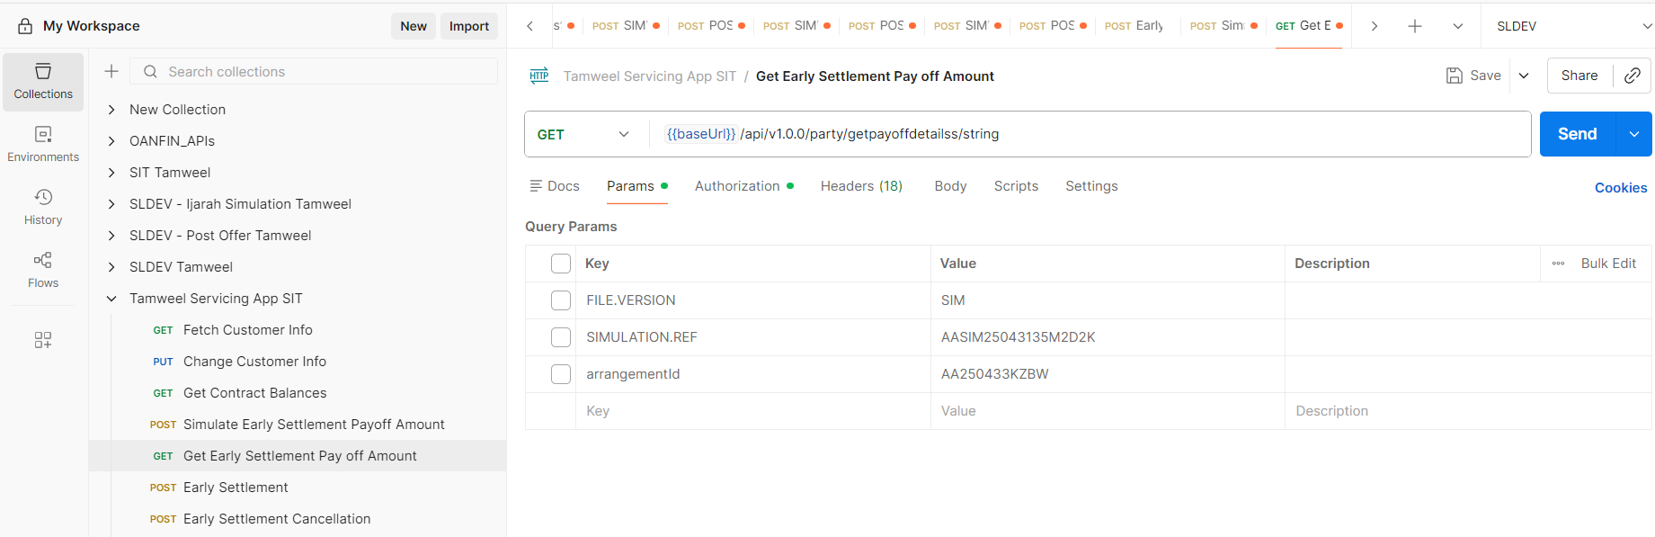
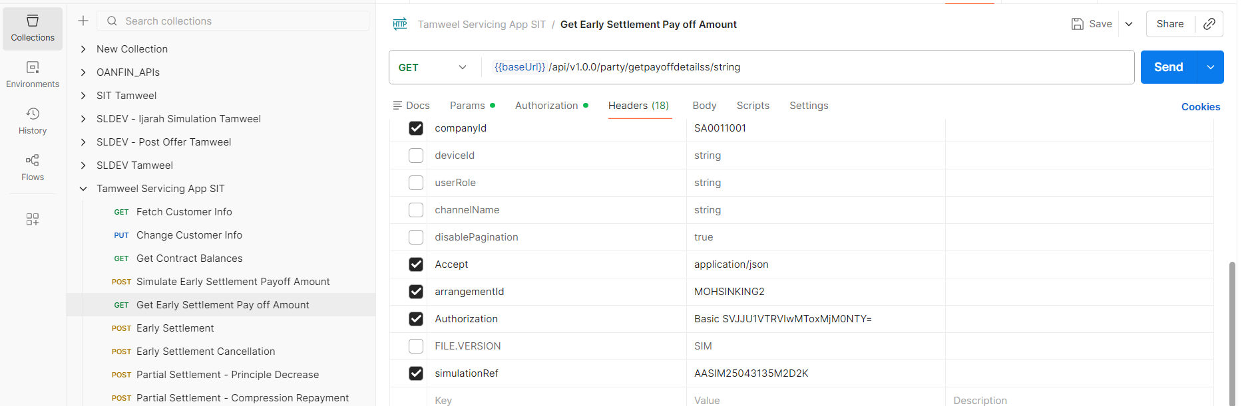
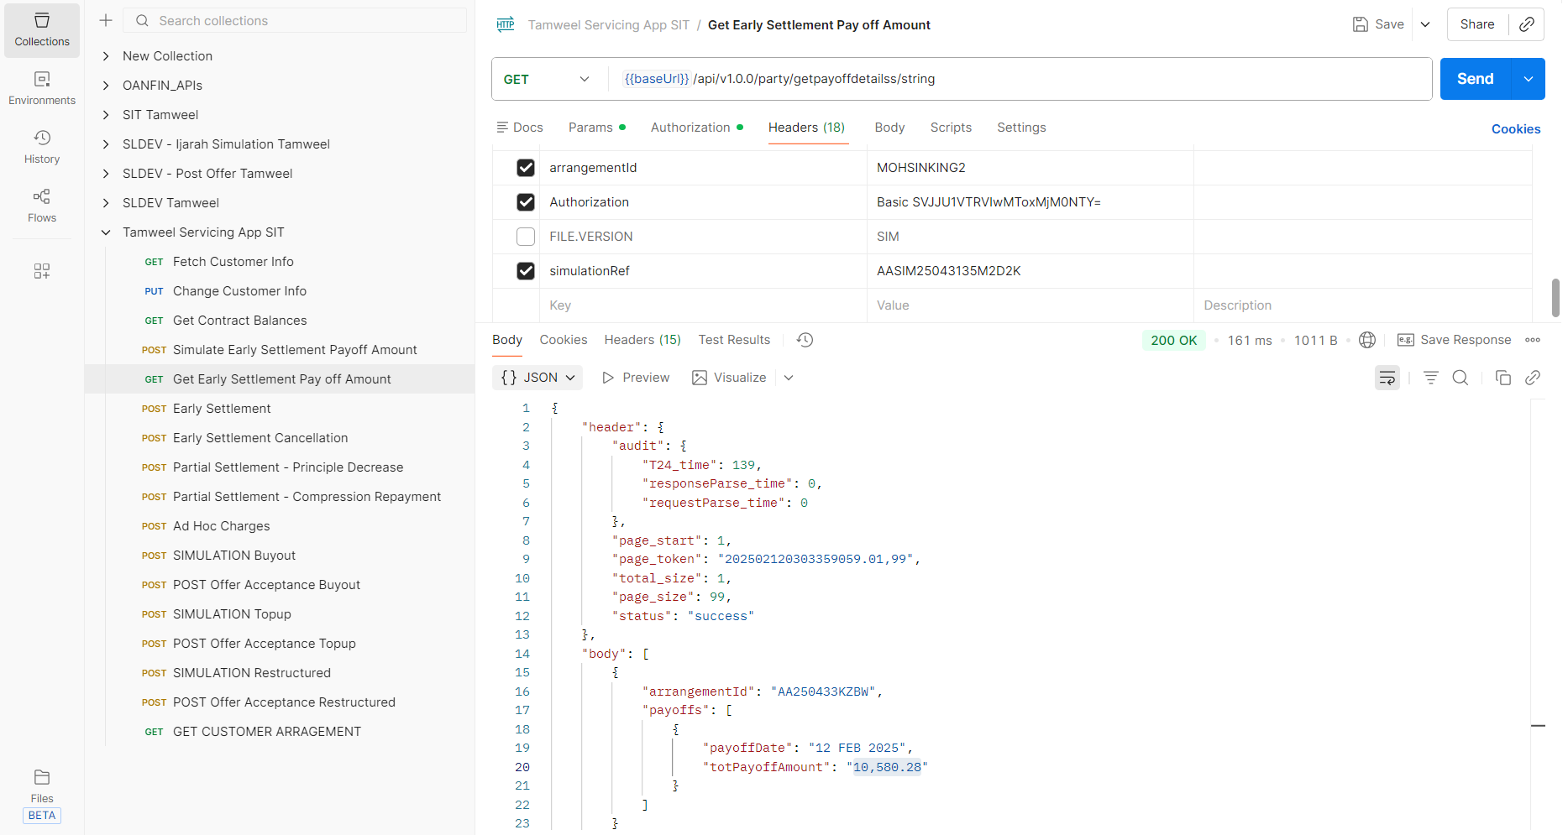
AA Simulation Capture
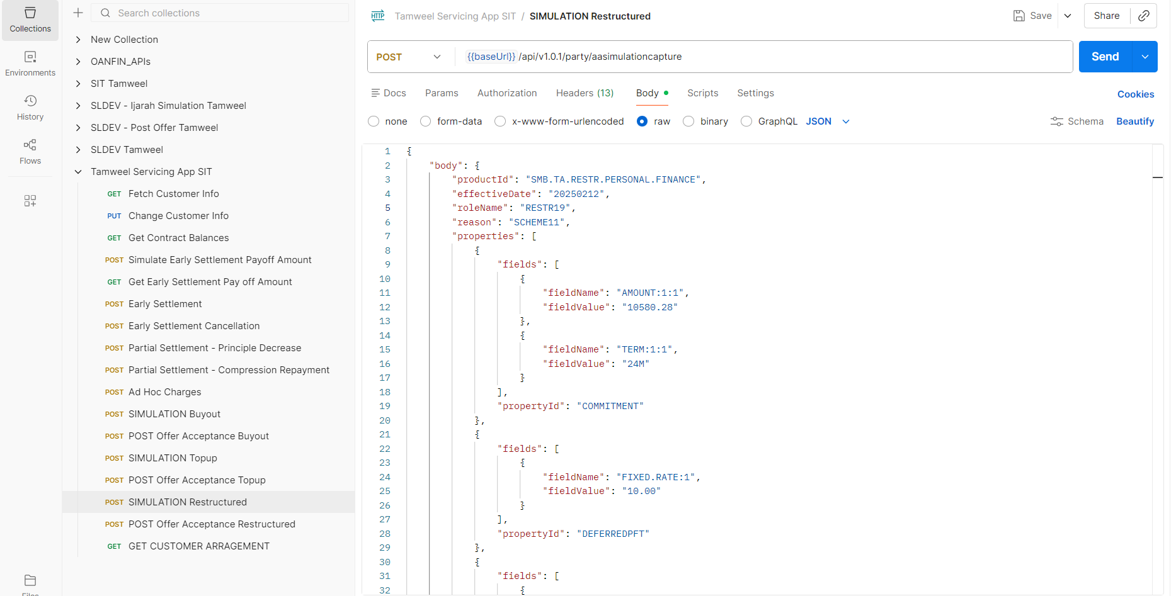
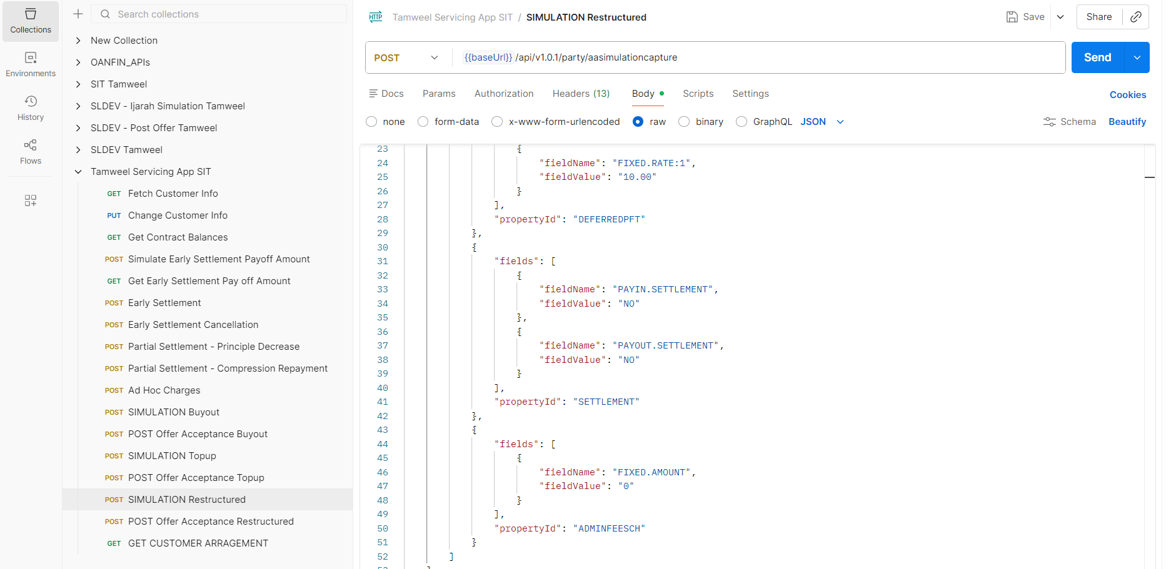
Post Offer Acceptance
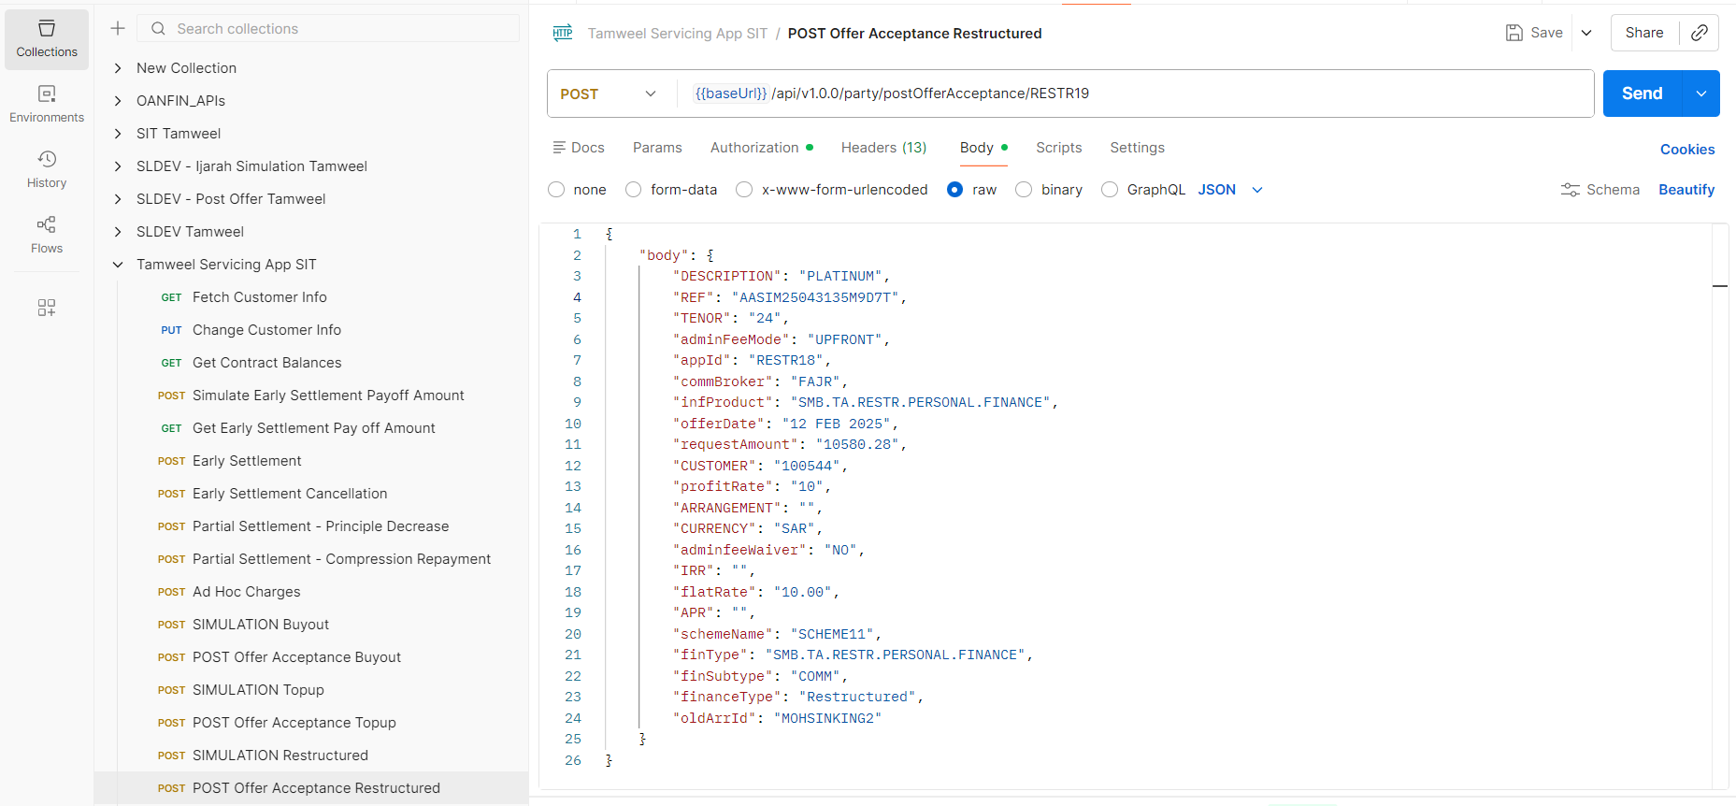
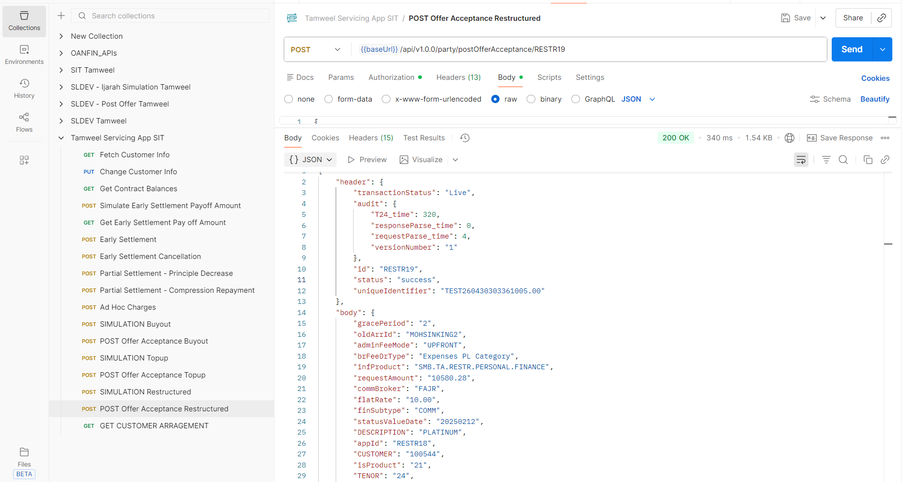
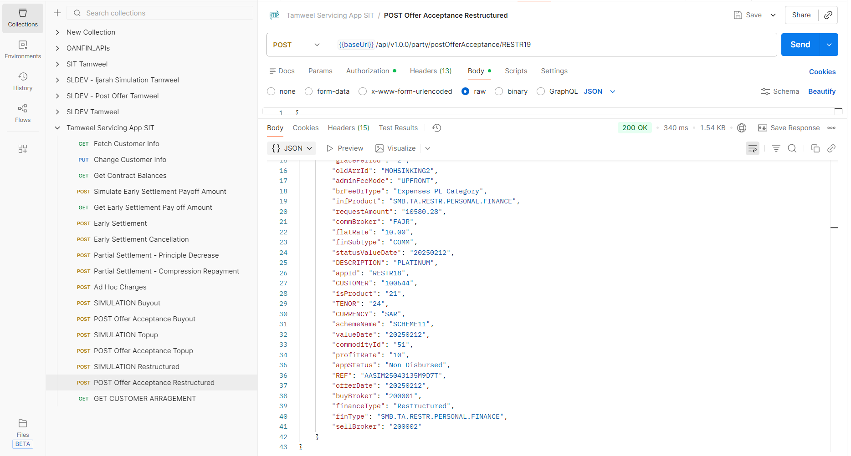

SMB Deal Details
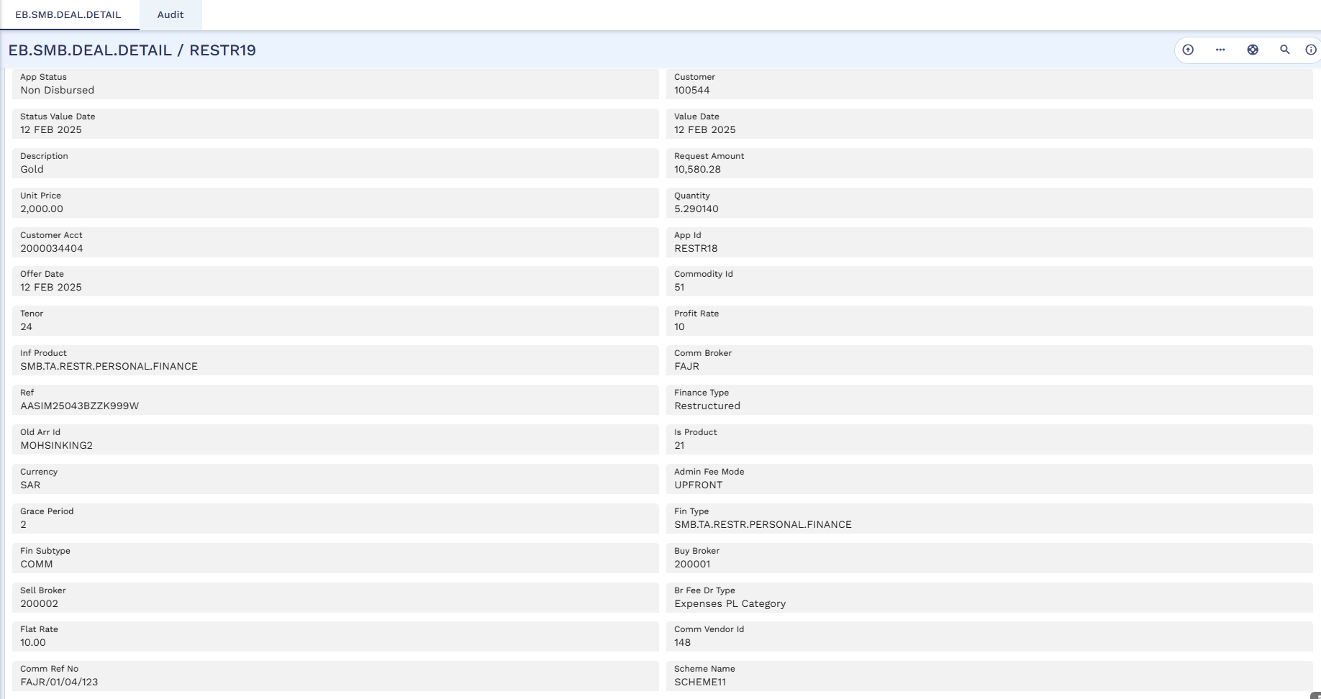
STP Status Enquiry
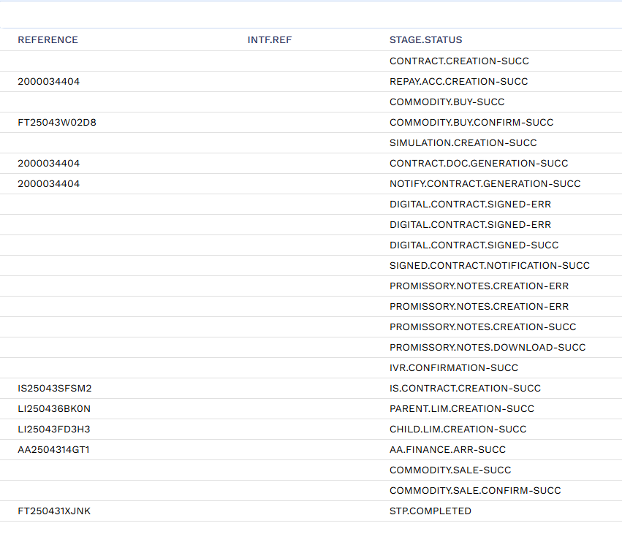

Arrangement
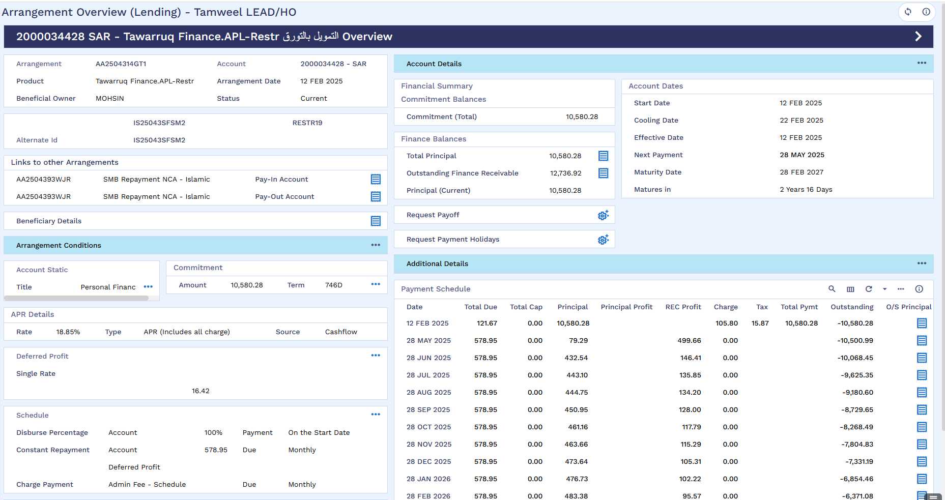
STP Accounting Entries
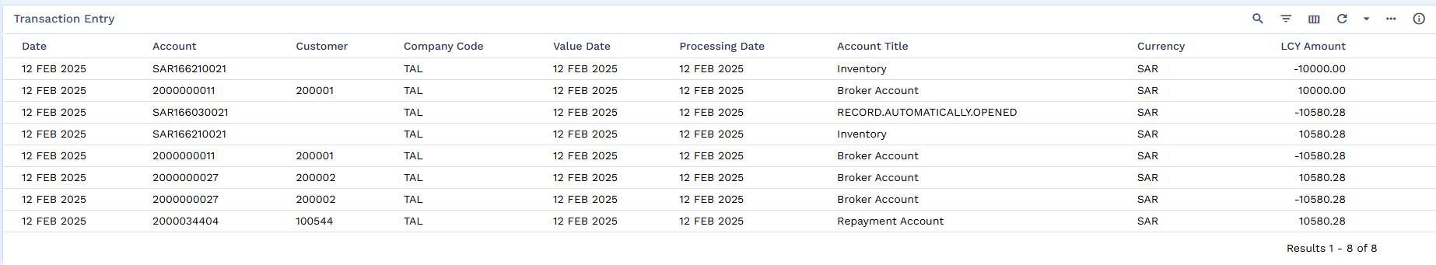
List of Transaction Entries
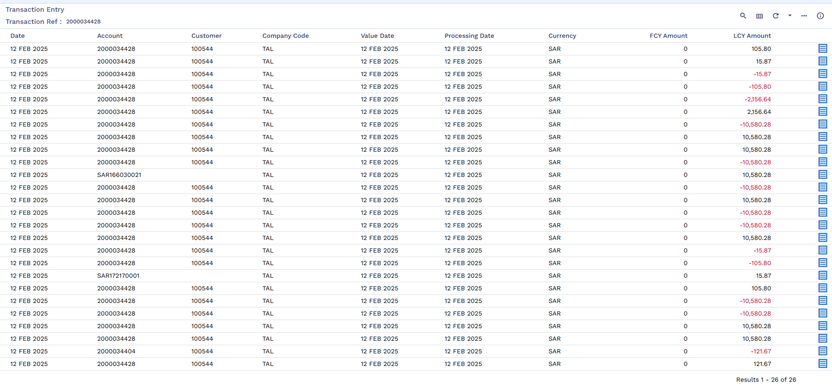
Repayment Account
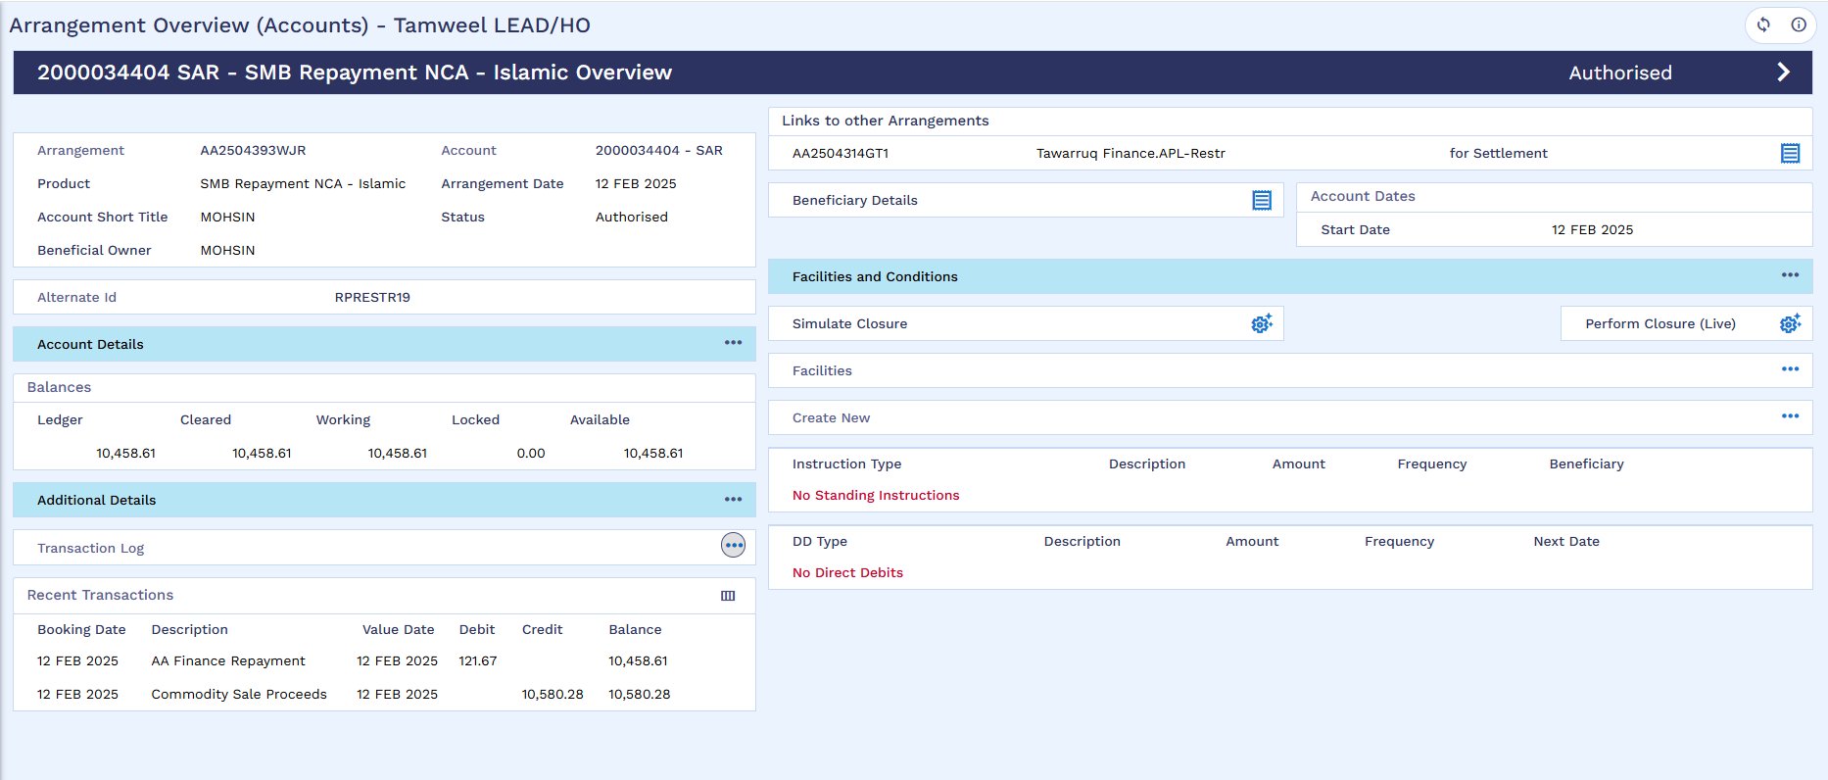
Now old arrangement will be settled through pay-off
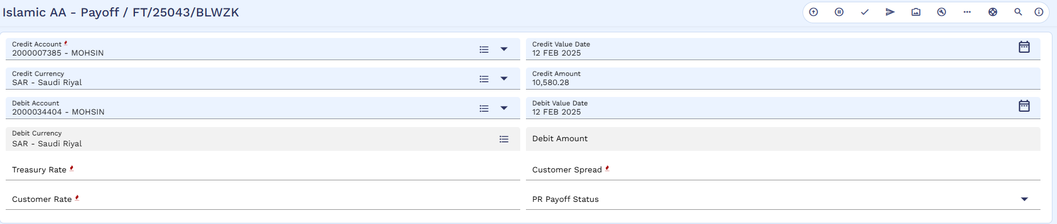
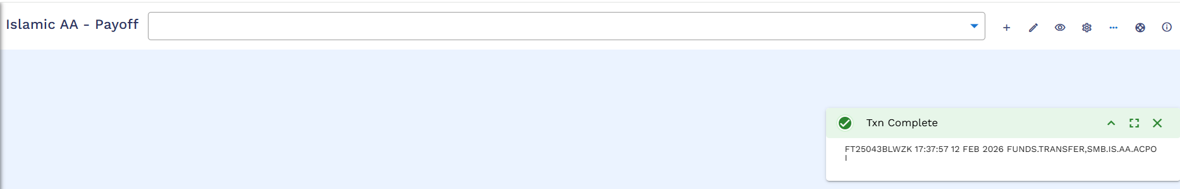
Authorization
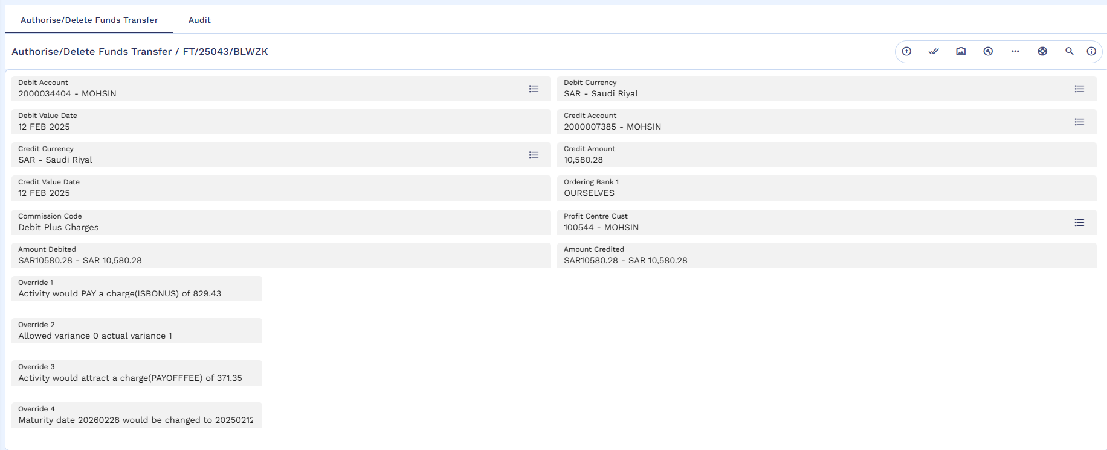
Arrangement Status Changes to Pending Closure
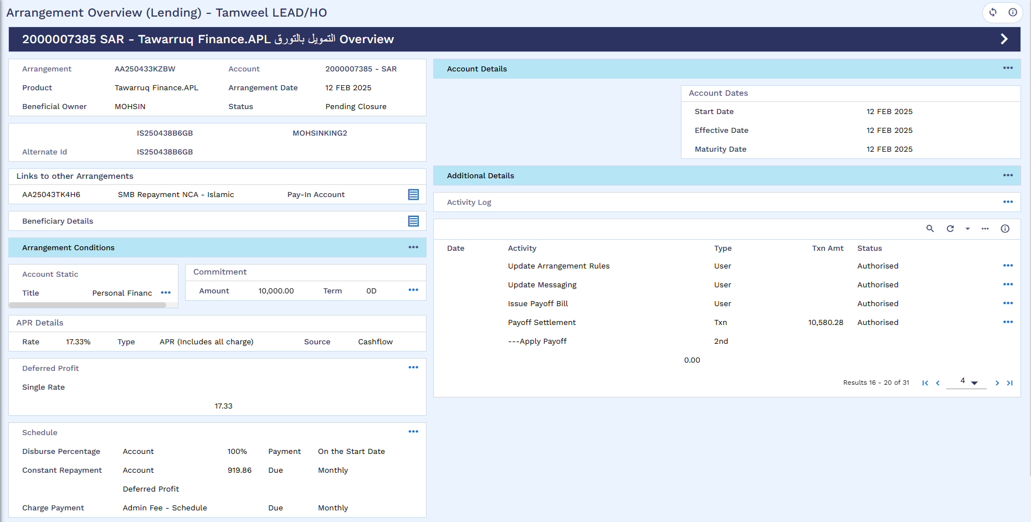

Top-up Facility
Simulate Early Settlement Payoff Amount
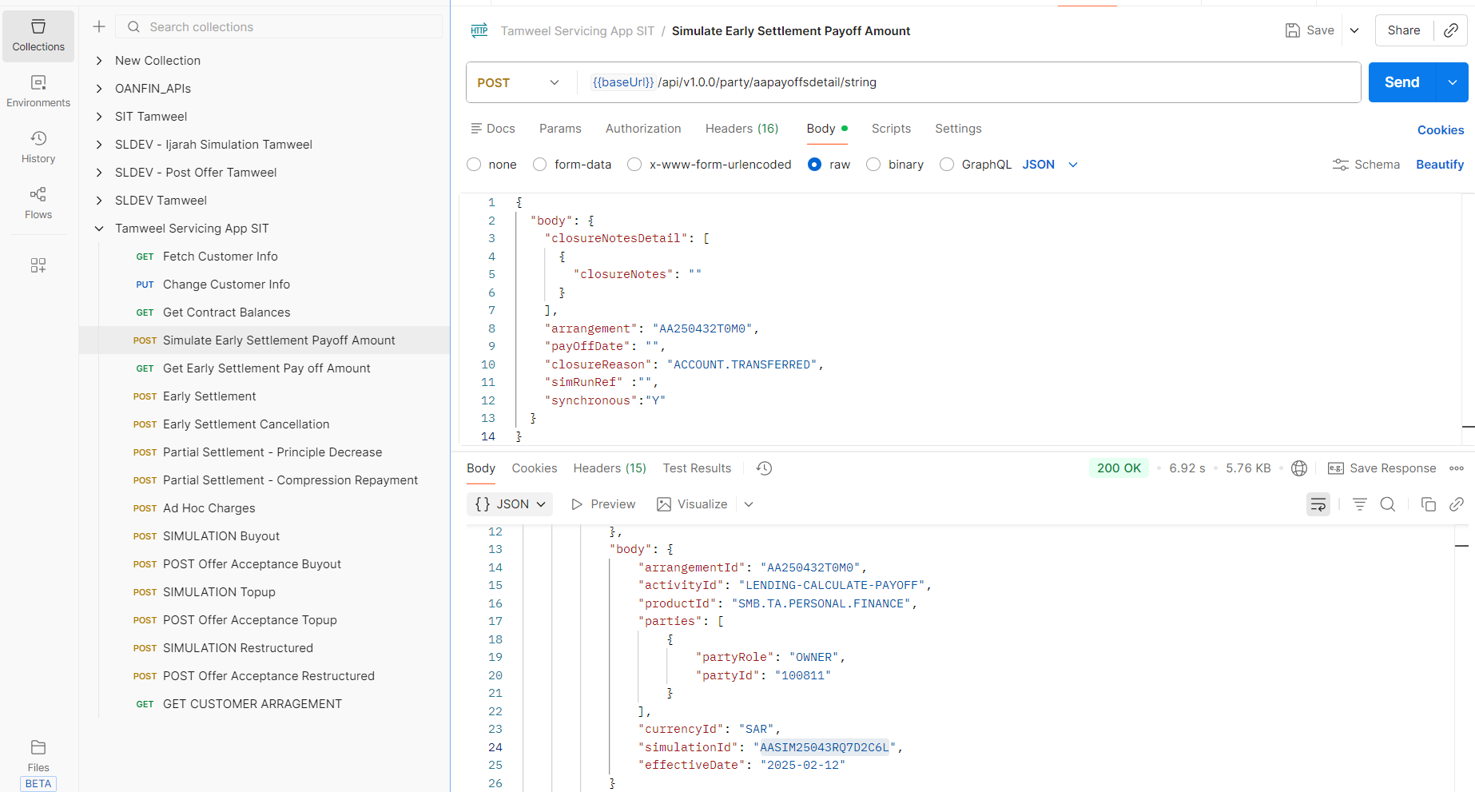

Early Settlement Pay off Amount
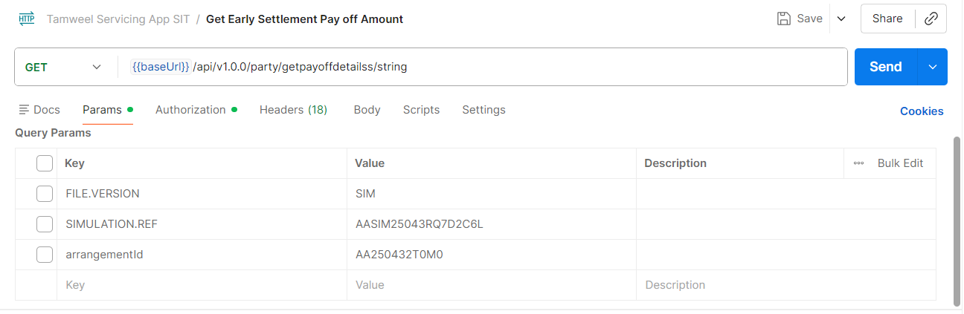
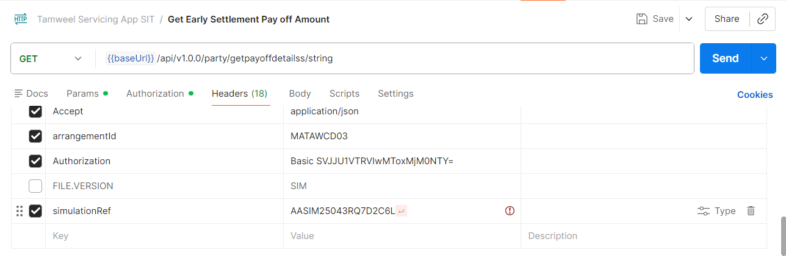
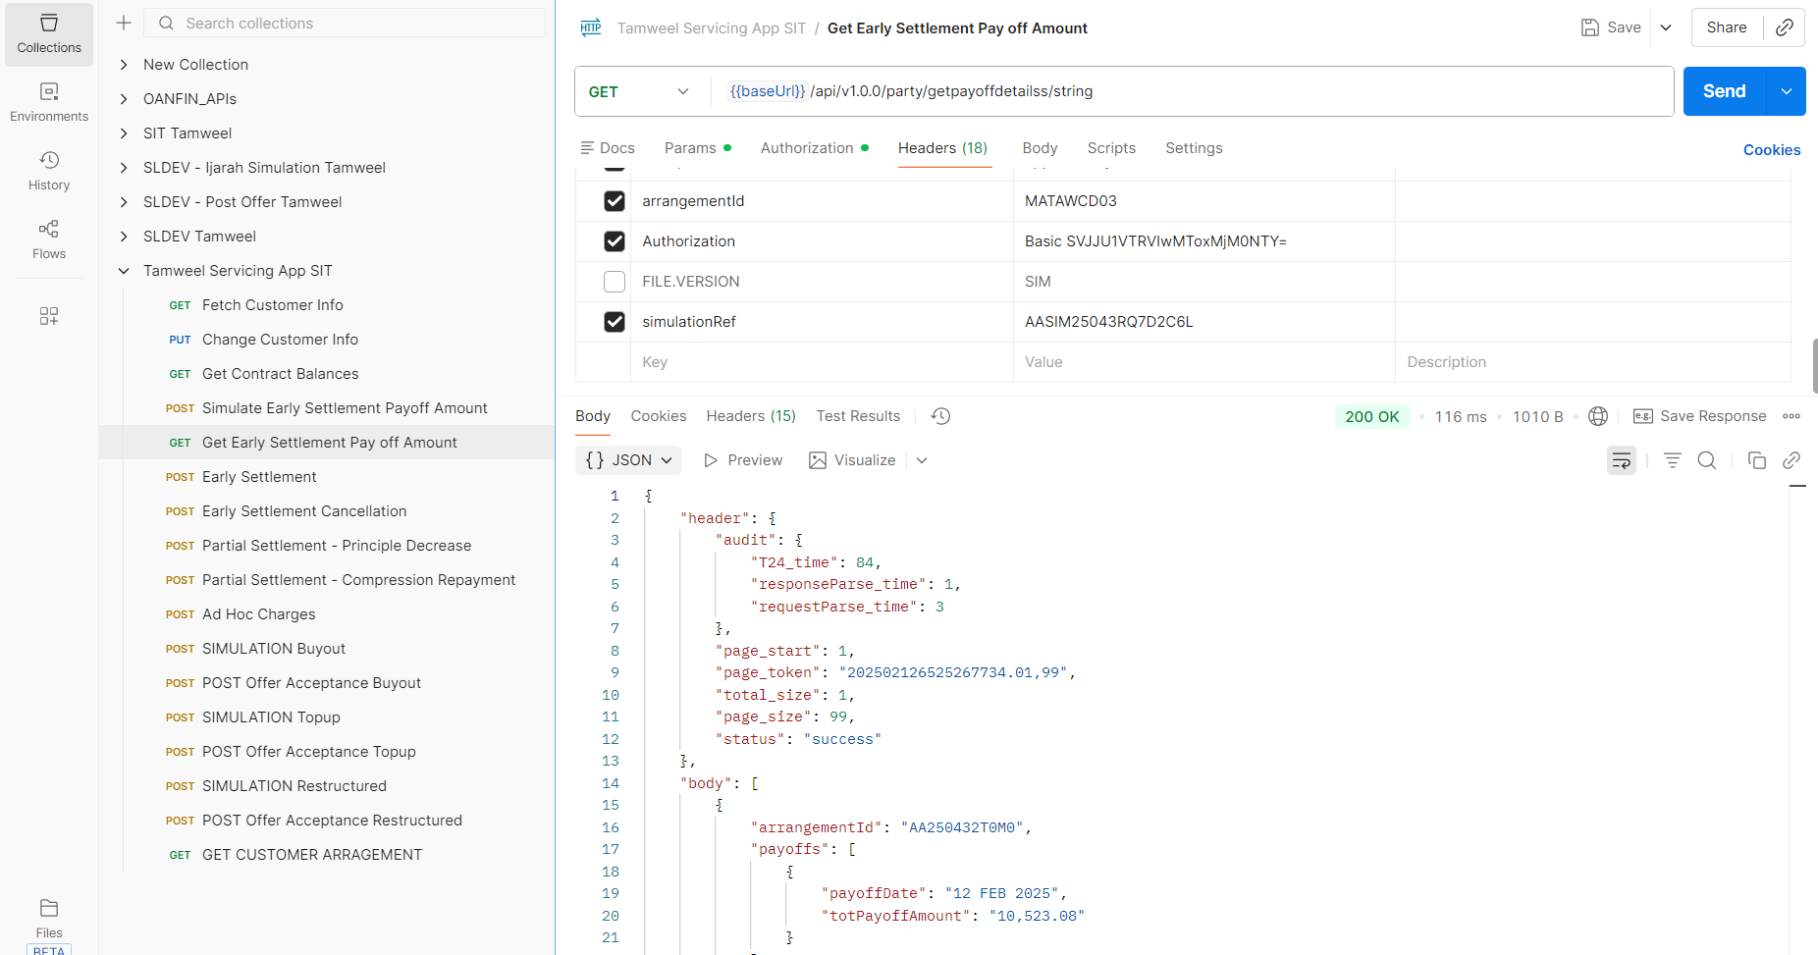

Simulation Capture
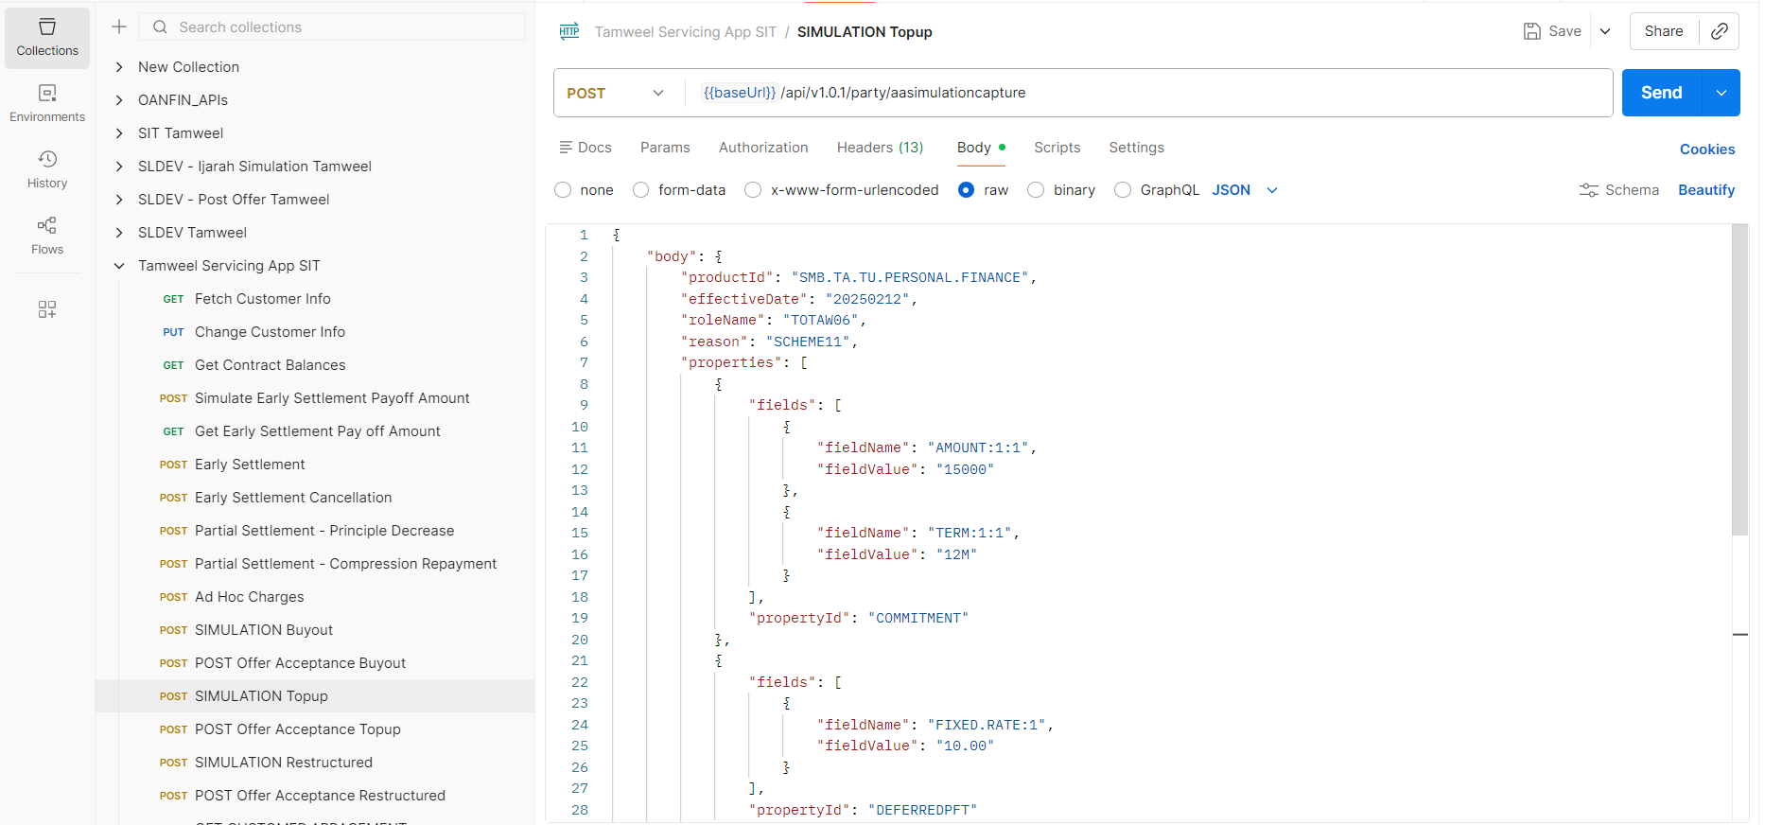
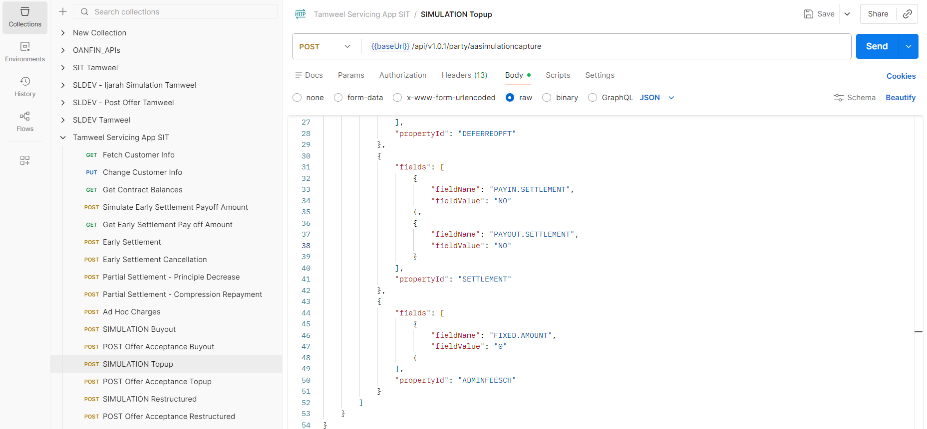
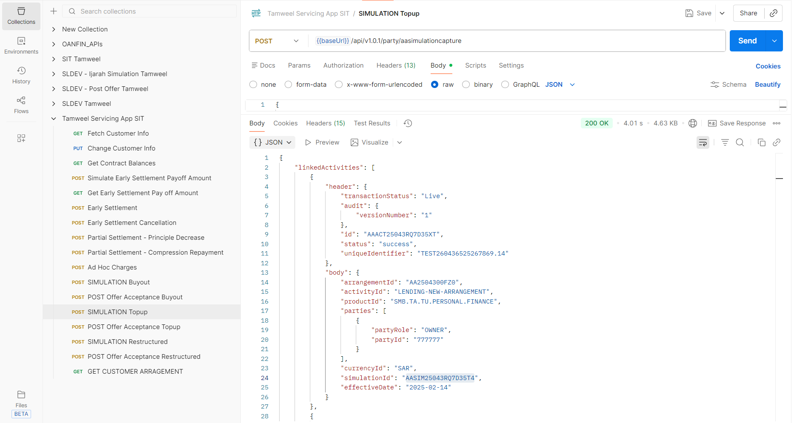
Post Offer Acceptance
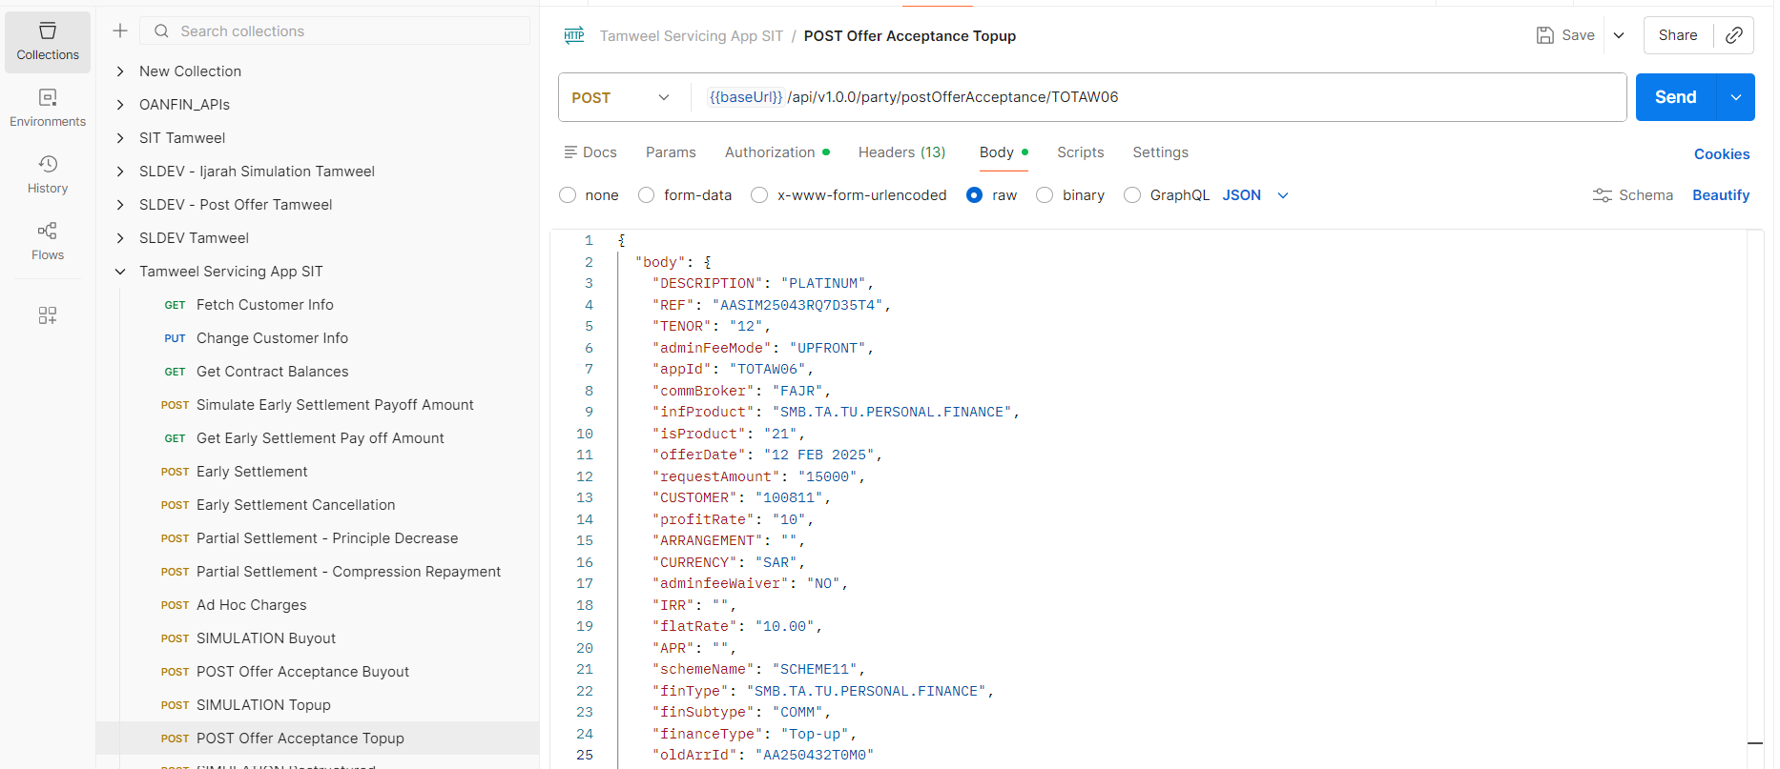
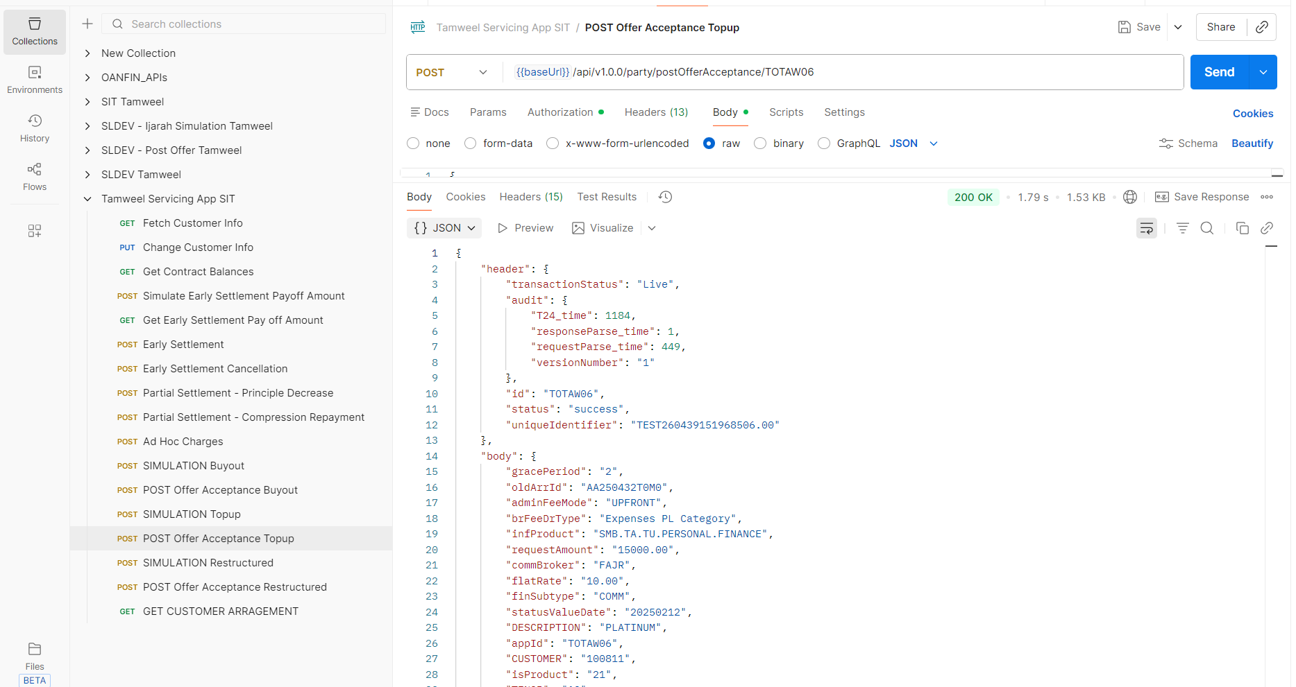
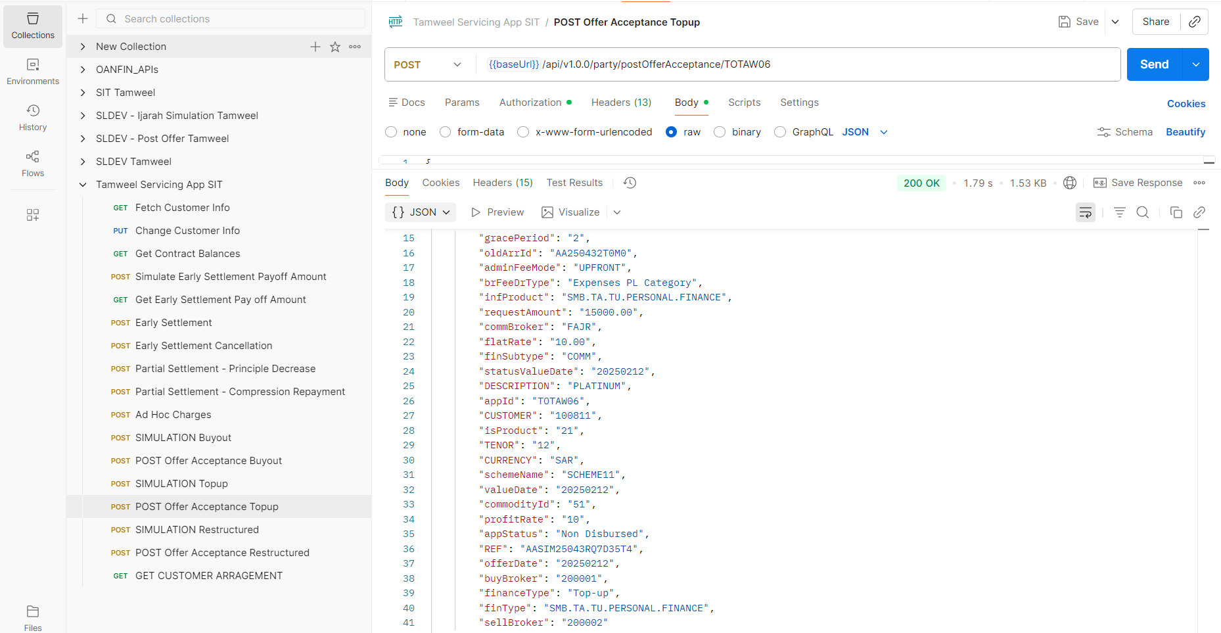

Simulation
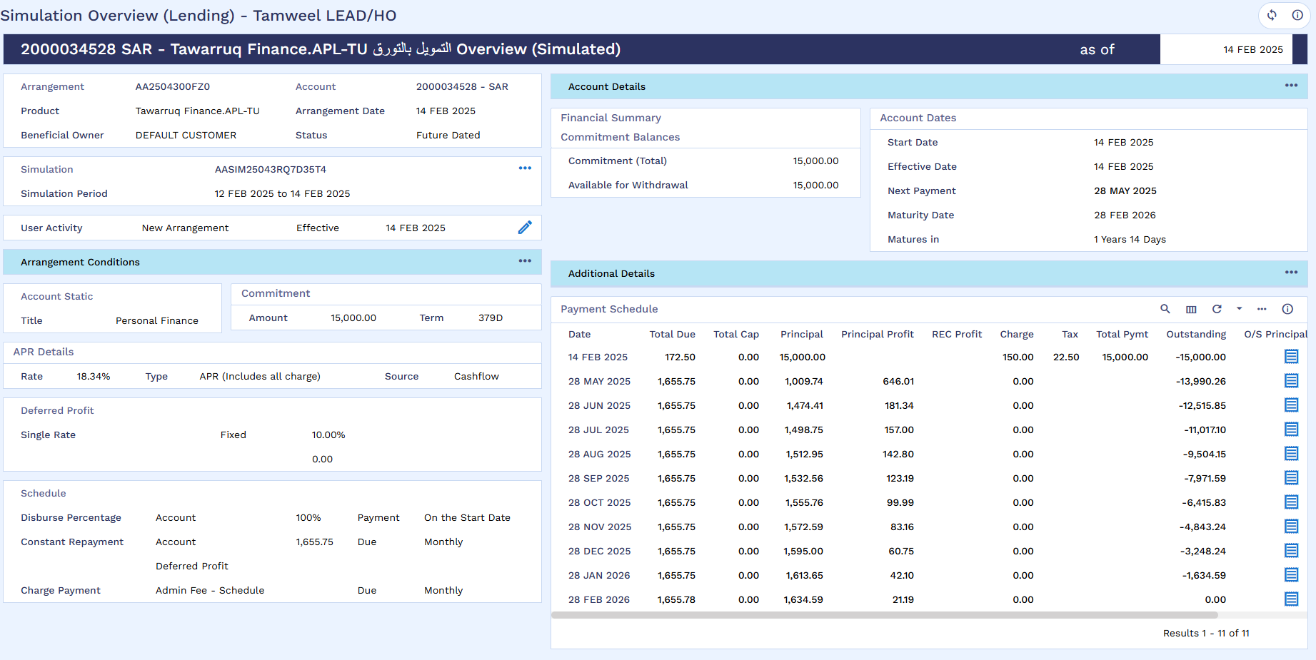
SMB Deal Details
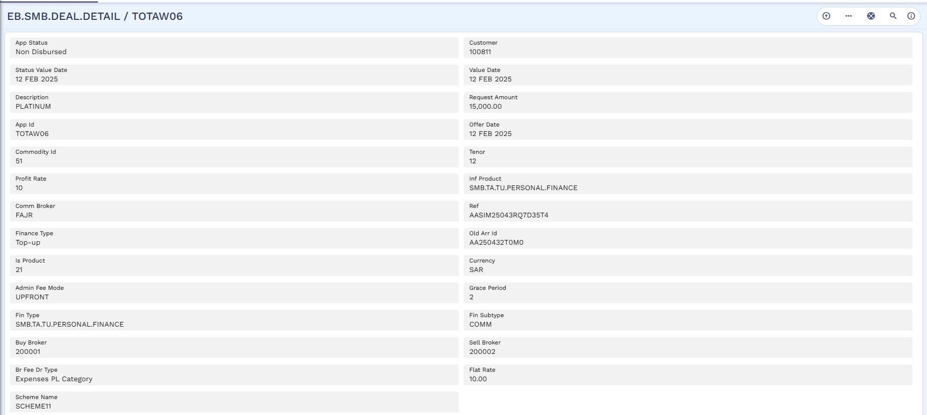

STP Status Enquiry
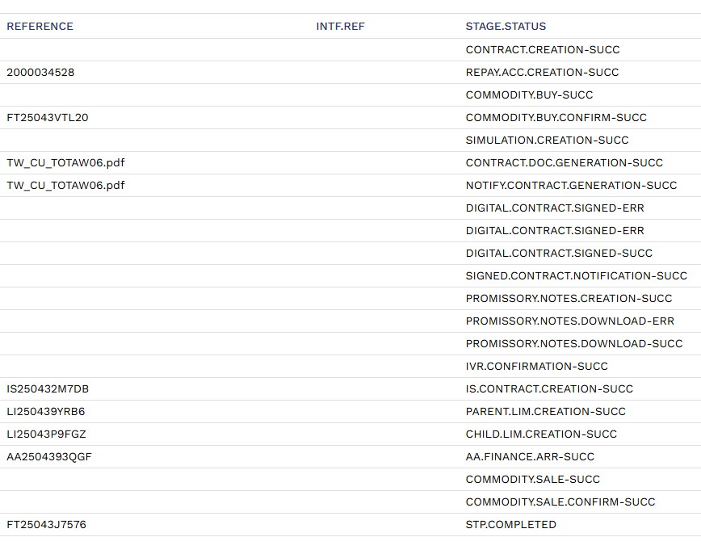
Top-up Arrangement
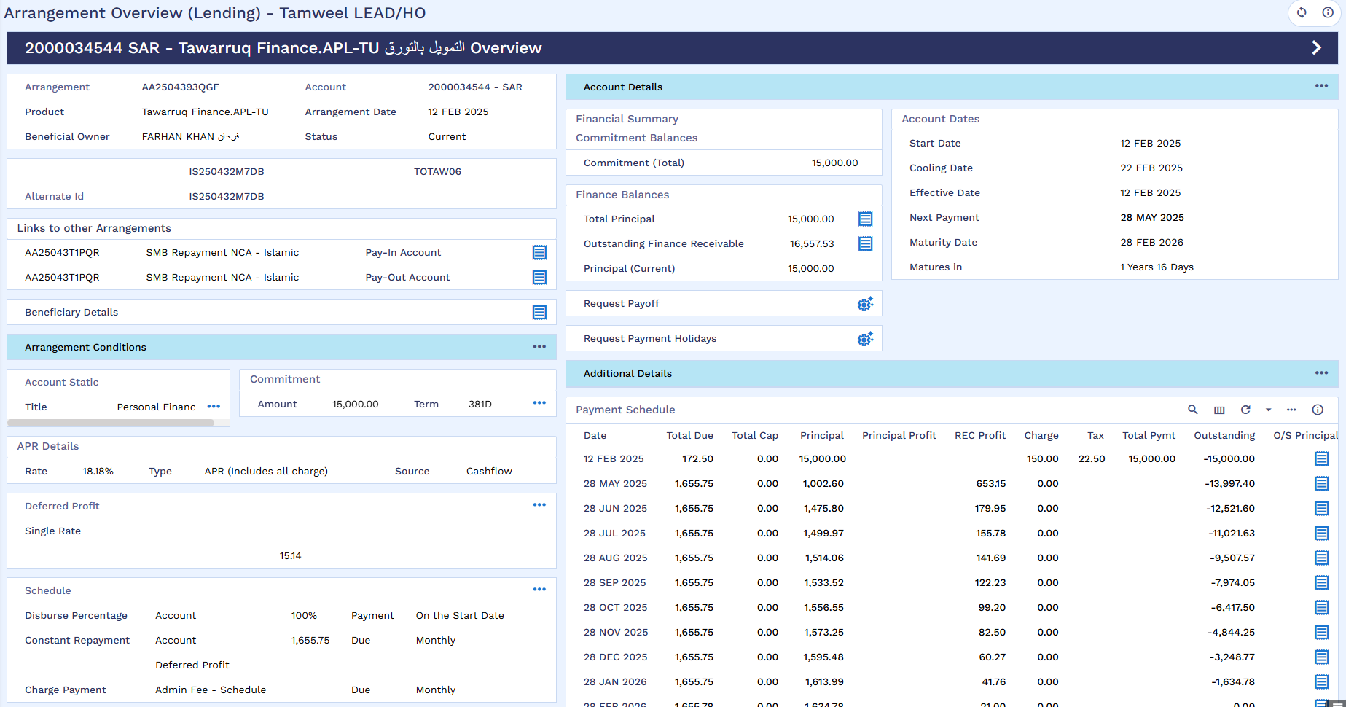
STP Accounting Entries
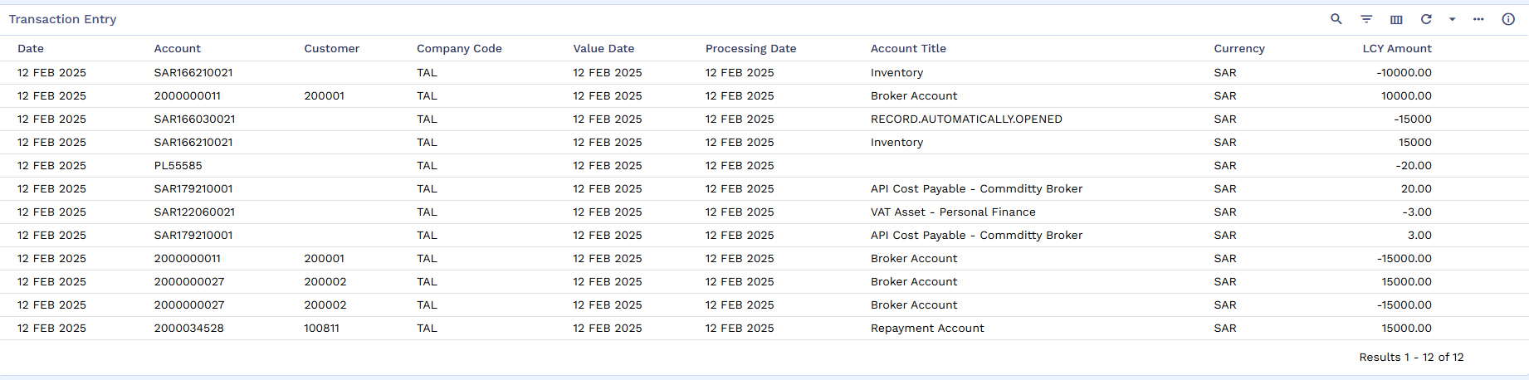
List of Transactions
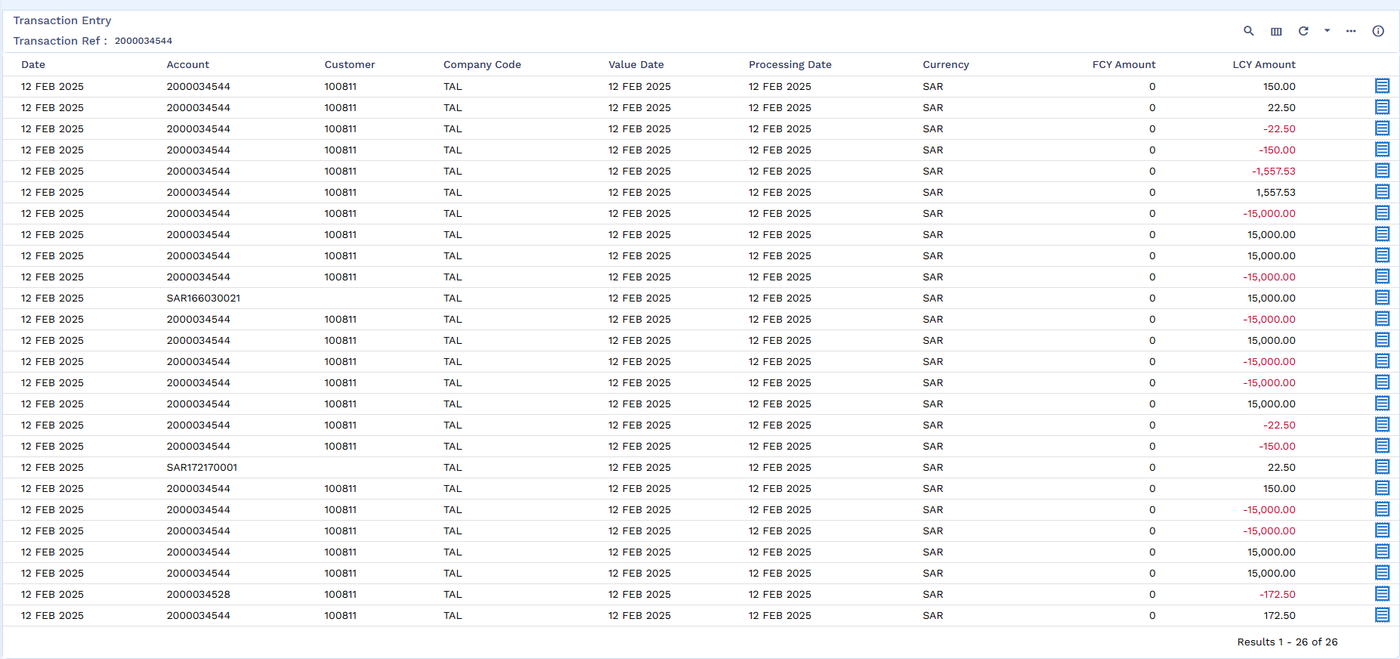
Now old arrangement will be settled through pay-off
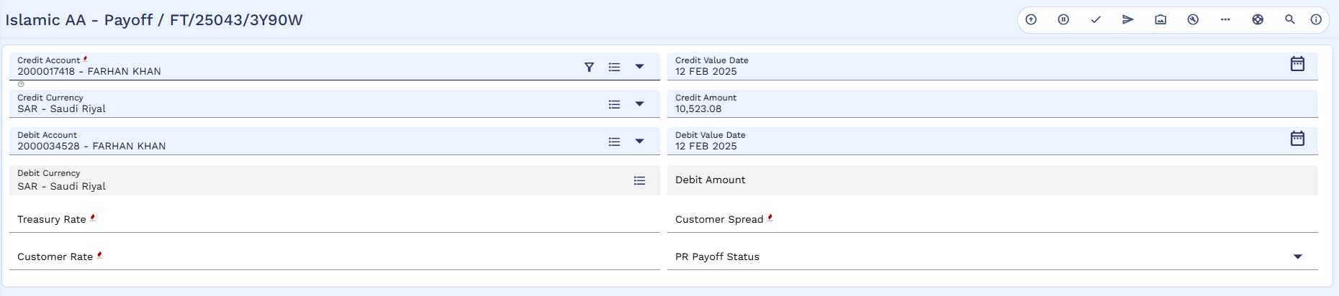
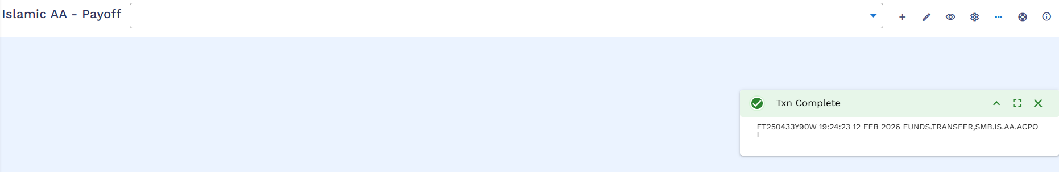
Authorization
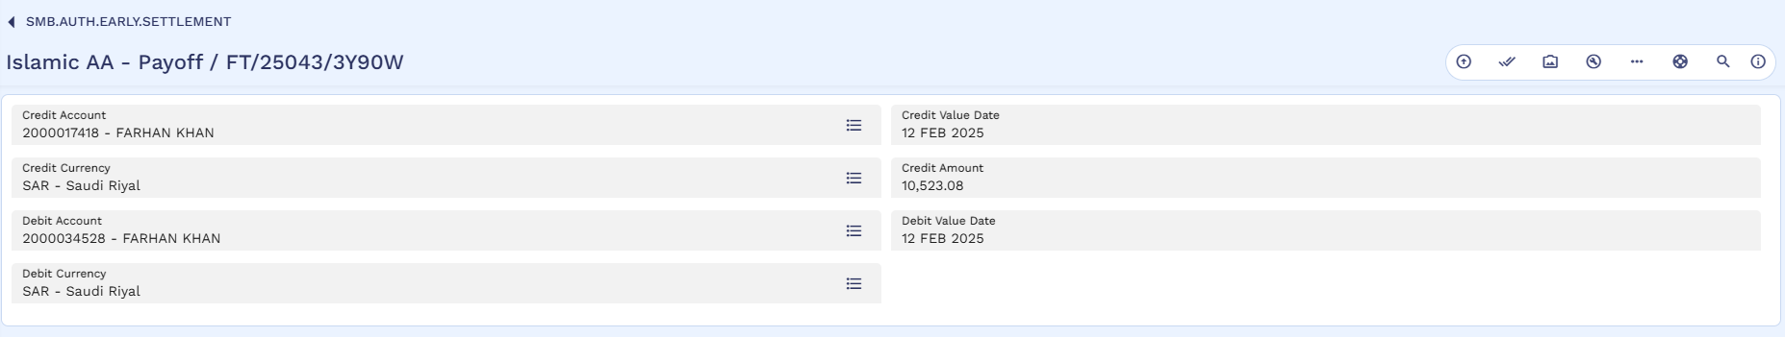
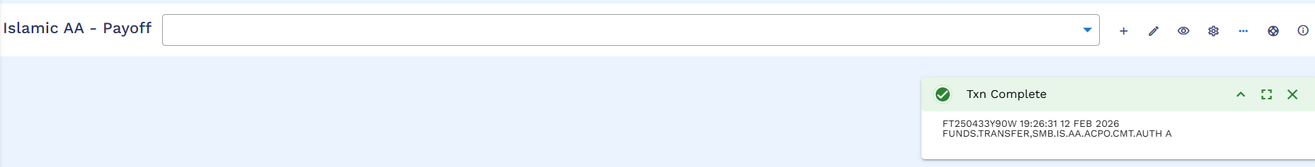
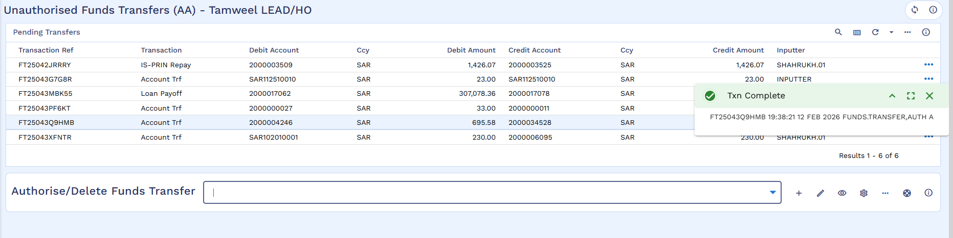
Repayment Account
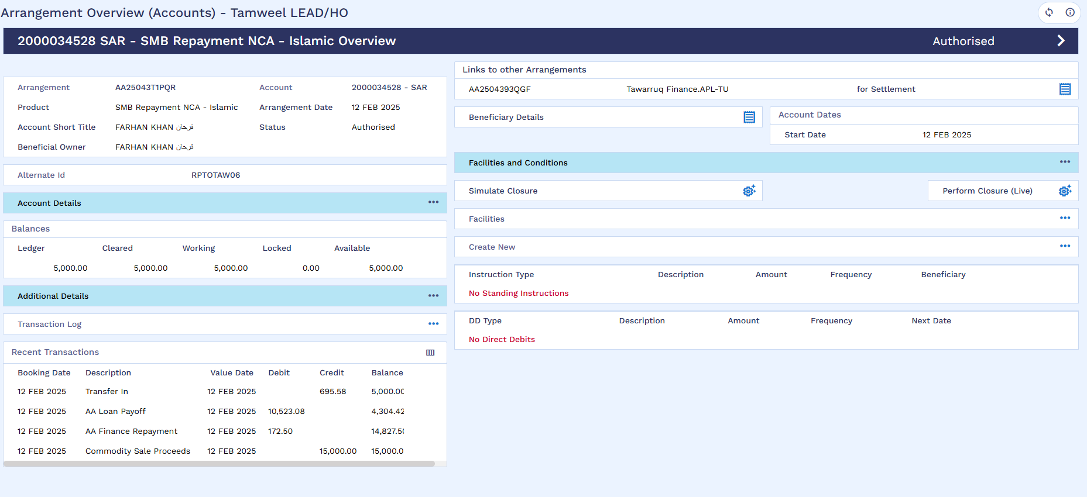

Now disbursement of excess SAR5,000 will be disbursed to the customer
AA Disbursement
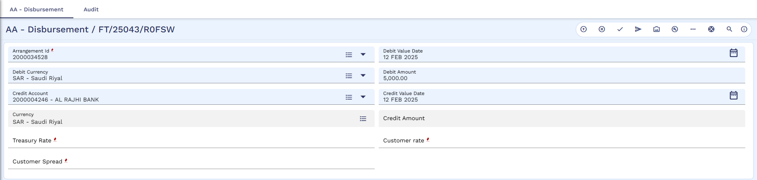
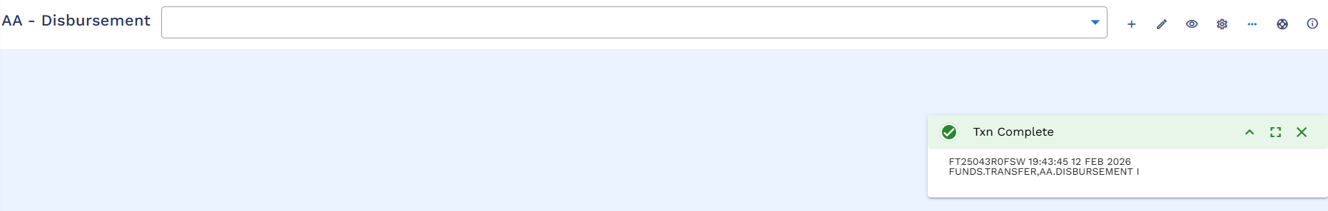
Authorization
